US History Online Learning
A1 Tuesday April 19th and B5 Wednesday April 20th
You are required to complete all of this work on your own and upload your answers on Canvas before midnight (Tuesday for A1 and Wednesday B5). This will count as your attendance in class and also for a 15 point Homework Grade. Read all the directions below and write answers on a separate document to upload to Canvas when it asks you to write answers:
- Overview:
Today we are starting Unit 8 from roughly 1950s-1970s (The Cold War, The Vietnam War, and 1960-70s Protest Movements)
-Unit 8 will be our last Test of the Year!!!!
-Here is the information you should prepare for:
Essay: Was the USA justified in entering the Vietnam War (examine causes, course, and effects of the Vietnam War)
Short-Answer: What are major theories of the Cold War? Give some evidence for each theory of The Cold War? What are 2+ 1960s-70s protest movements?
-Today you will start to learn about the start of The Cold War. In the Next class you will read about the start of The Vietnam War.

- Let’s quickly review Mr. C’s chart for World History in the 20th-21st Century: How can Mr C’s ‘Political Philosophy Chart’ be used to understand much of USA & World History in 1900s, 2000s, and maybe even today?

The Far Left  MARXISM  - Poor must do a violent revolution  - No democracy  - Set up a new system  - Communism- state redistributes $ equally  - Socialism- “workers/people’ redistribute $ equally  -WHAT IS A ‘TOTALITARIAN STATE’? | The Left  DEMOCRATIC-LIBERALISM  - Yes keep democracy  - Regulate capitalism to make more fair for all  - Government provide services to help poor compete in free market  - Expand democracy & people control of state | The Right  LAISSEZ-FAIRE CONSERVATISM  - Yes keep democracy  - NO government or state interference of free capitalism  - Let capitalism and free business fix problems  - Trickle-Down Economics (Top 10% so wealthy they expand business & create new jobs) | The Far Right  FASCISM  - NO democracy  - Top 10% wealthy + military total control of government and society  - Create a permanent military + war state for constant growth & expansion  - State total control of society  - Problems blamed on “outsiders” or “minorities”

Let’s start to answer some questions to upload to Canvas:
QUESTION #1: Looking at the chart above- how can you use this chart to understand..
- What was World War II (1940-1945)?
- What will be The Cold War (1950s-1970s)?

Now let’s quickly introduce ‘Different Theories of The Cold War’
Different historians and different countries’ History textbooks understand what was happening during ‘The Cold War? Differently. Here are the 3 major theories and a brief explanation of each theory:

THEORY #1: USSR MENACE THEORY- this theory is popular in USA History textbooks and it argues that ‘The Cold War’ is all USSR’s fault. In the 1950-70s the USSR is trying to spread Communism around the world. Therefore the USA ‘saves the day’ again and protects the world from communism spreading. Therefore, the USA will fight small wars all over the world to “stop the spread of communism” and “help the growth of democracy around the world.”
THEORY #2: USA IMPERIALISM THEORY- this theory is popular in USSR History textbooks and it argues that ‘The Cold War’ is all USA’s fault. After World War II the USA is the only superpower in the world. In the 1950s-70s the USA will try to dominate and control as much of the rest of the world as it can. It wants to set up dictators around the world that will be friendly to USA military and economic interests. Of course, the USA doesn’t tell its people or the world it is trying to conquer the world; instead, it tells people that it is ‘trying to spread democracy.’ The USSR lost 10 million people in World War I and 20 million people in World War II. The USSR was never a strong power in the 1950s-70, but rather was only trying to protect itself from being invaded again.
THEORY #3: ORWELL THEORY- this theory is named after 1984 and Animal Farm author George Orwell. It argues that ‘The Cold War’ is equally the fault of the USA and USSR. Both the USA and USSR want to conquer as much of the world as they can, and they both use each other as justification to do this. Why is this called the COLD war? Because the USA and USSR will never fight with each other; but they will fight many wars against other smaller countries to control them. In the end, there is not much difference between the USA and USSR- they are both equally fascist in this theory’s opinion.
SO AS YOU READ ABOUT THE COLD WAR- YOUR JOB IS TO LOOK FOR EVIDENCE THAT CAN FIT EACH OF THESE THEORIES!!! SO LET’S GET STARTED AND WRITE SOME ANSWERS!
Open up the online textbook:
Click on My website: www.mrciambarellaclass.com Click on US Unit 7-9
Click on Week 4 LINK TO THE AMERICANS TEXTBOOK
Click on CH 18 Cold War Conflicts
Click on -18.1 Origins of The Cold War
Quickly Read over pages 603-605
QUESTION #2: After reading over pages 603-605 give some evidence you see on these pages that would support either Theory 1, 2, or 3 above and why? (you can answer in sentences or bullet points is OK)

Now Quickly Read over pages 606-608
QUESTION #3: After reading over pages 606-608 give some evidence you see on these pages that would support either Theory 1, 2, or 3 above and why? (you can answer in sentences or bullet points is OK)

Now Go back and click on 18.2 The Cold War Heats Up
Quickly Read from the bottom of page 609 “China becomes a communist country”- and all of page 610.
QUESTION #4: After reading over pages 609-610 give some evidence you see on these pages that would support either Theory 1, 2, or 3 above and why? (you can answer in sentences or bullet points is OK)

Now Quickly Read over pages 611-615
QUESTION #5: After reading over pages 611-615 give some evidence you see on these pages that would support either Theory 1, 2, or 3 above and why? (you can answer in sentences or bullet points is OK)
So far all of the evidence we have examined comes from a USA History textbook, so perhaps the evidence and explanations are somewhat ‘biased.’ Finally let’s look at some other evidence about The Korean War from a different perspective. Read the following excerpt I paste below from an article from Source: http://peacehistory-usfp.org/korean-war/
After you read over this excerpt finally answer
QUESTION #6: What is some evidence from this article that can be used as evidence for Theory 1, 2 , or 3 above and why.

So read over the following excerpt below and then upload your answers to these 6 questions on Canvas before midnight.

Here is the article to read for Question #6:
Part Four: Bombing ‘em back to the Stone Age: Aerial techno-war over North Korea
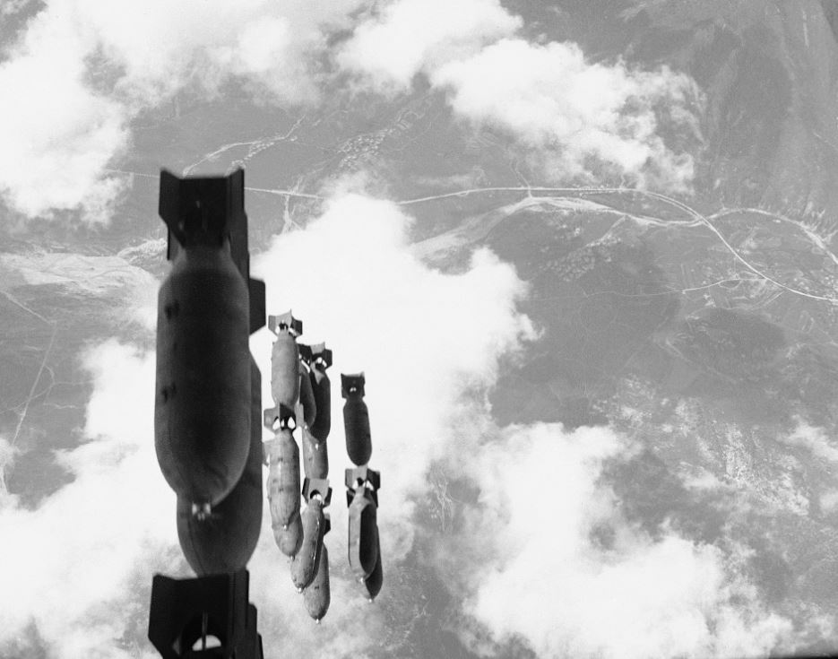
U.S. bombs fell on South Korea as well as on North Korea. Salvo of 500-pound bombs dropped from a U.S. B-29 on communist-controlled territory west of the Naktong River, Aug. 16, 1950 (AP photo)
The American Caesar, General Douglas MacArthur, was a boyhood friend of air power prophet Billy Mitchell, who had served under his father, Arthur, in the Philippines. Like Mitchell, Douglas MacArthur’s worldview had been shaped by the horror of the trenches of World War I and he had adopted the view that since war was so horrible, whoever unleashed it should be obliterated; and that, in a righteous cause, there was no substitute for victory.[129]
In the latter spirit, MacArthur had warned that if the Chinese intervened, “our air power will turn the Yalu River into the bloodiest stream in all of history,” which is not far removed from what happened.[130] From air bases in Okinawa and naval aircraft carriers, the U.S. Air Force launched over 698,000 tons of bombs (compared to 500,000 in the entire Pacific theater in World War II), making use of innovations like in-flight refueling systems, faster and more nimble engine-driven machines, and ground-radar controlled missions allowing for night bombing which Lt. Gen. Edwin M. Almond of X Corps called “an epic in our warfare.”[131]
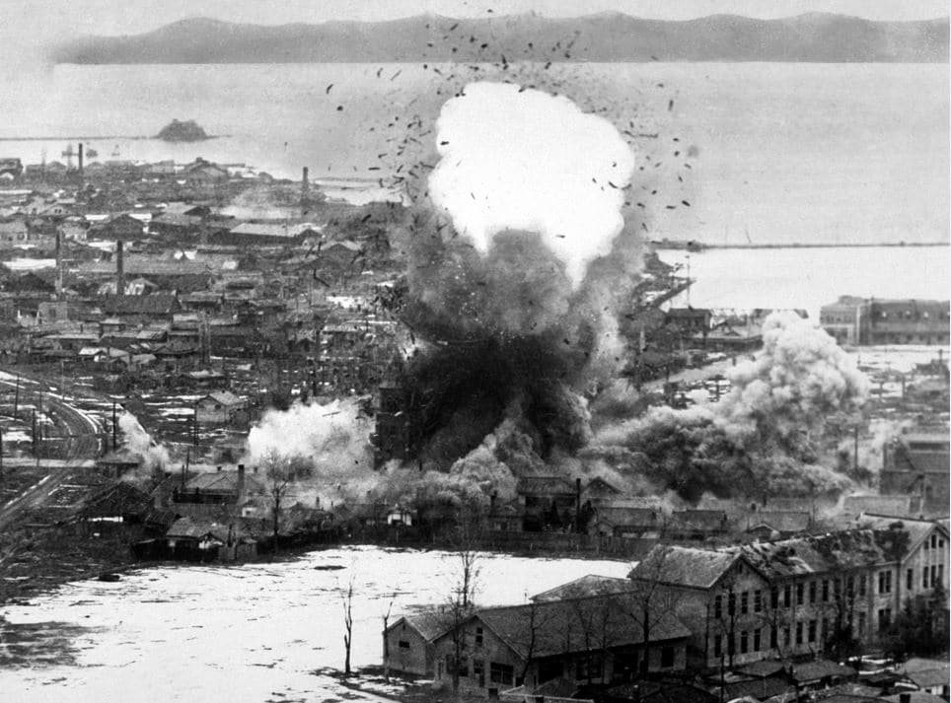
US Air Force bombers destroy warehouses and dock facilities in Wonsan, North Korea, 1951 (US Dept of Defense-USIA)
Much of North Korea was left, in Maj. Gen. Emmett O’Donnell Jr.’s words, a “terrible mess,” with thousands of Chinese slaughtered, an estimated one million civilian casualties and hundreds of thousands of refugees. Some of those refugees were napalmed by U.S. pilots under orders to “hit anything that moved.” Eighteen out of 22 cities were obliterated, including 75 percent of Pyongyang and 100 percent of Sinuiju. Gen. Curtis LeMay, head of the Strategic Air Command during the Korean War, later told an interviewer:
We slipped a note kind of under the door into the Pentagon and said, “Look, let us go up there…and burn down five of the biggest towns in North Korea – and they’re not very big – and that ought to stop it.” Well, the answer to that was four or five screams – “You’ll kill a lot of non-combatants,” and “It’s too horrible.” Yet over a period three years or so…we burned down every town in North Korea and South Korea, too… Now, over a period of three years this is palatable, but to kill a few people to stop this from happening – a lot of people can’t stomach it.[132]
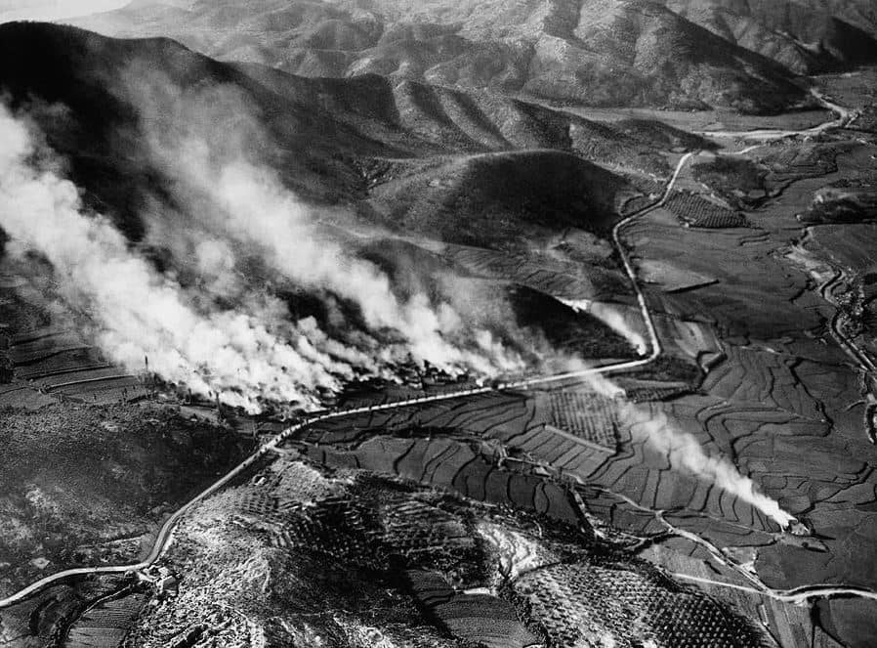
Village of Agok in northern region of North Korea hit with missiles, August 1950
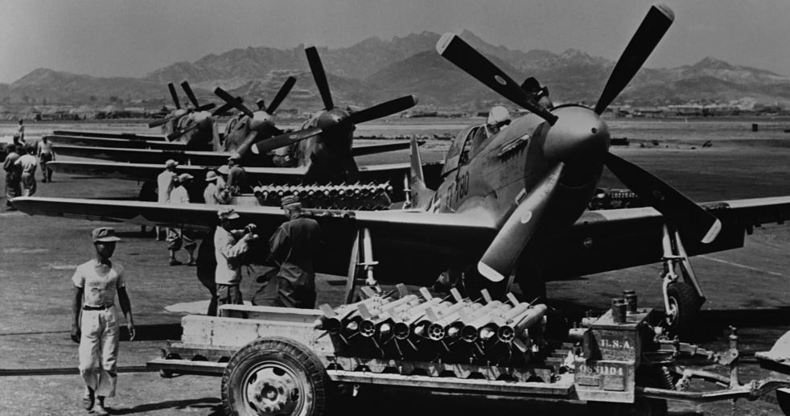
U.S. fighter aircraft loaded with rockets
Push-button warfare was directed predominantly at major industrial plants in North Korea as well as railroads, bridges, communications centers and the electrical grid. Schools and hospitals were also badly damaged or destroyed along with Kim Il Sung University, archeological sites, and treasured historical monuments such as the Kwangbop Buddhist temple dating to 392 A.D, the Potang City gate, the Sungryong Hall temple dating to 1429, and the Yang Myong temple dating to the 14thcentury.[142] DPRK leaders hid in deep bunkers, while villagers were forced to live in holes dug in the rubble of cities and sides of hills and caves where disease proliferated.
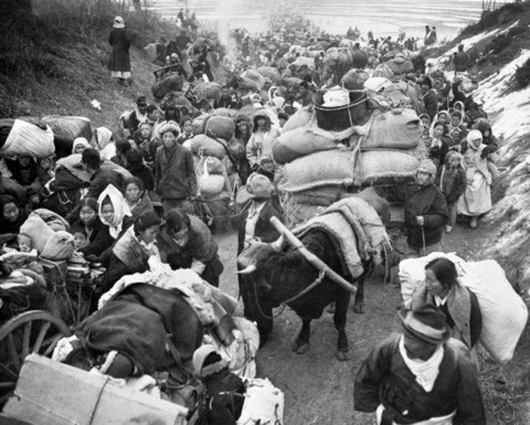
Battle-weary Korean civilians crowd a Korean road in late January 1951, seeking safety from the continuous fighting (UN Photo Archive).
Racial dehumanization was a pivotal factor accounting for the lack of American restraint in targeting civilians. MacArthur believed that “the Oriental dies stoically because he thinks of death as the beginning of life.” American bombers dropped thousands of leaflets warning civilians to stay off roads and away from facilities that might be bombed, but independent observers noted that American ground forces were much too “quick to call in overwhelming close air support to overcome any resistance in flammable Korean villages.”[146] Pilots were often under orders not to return with any bombs. According to Australian journalist Harry Gordon, who rode along in a B-26 Intruder, they would attack anything that moved, including ox-carts, resulting in “needless slaughter.”[147]
Mission reports at the U.S. National Archives provide a window into the detachment of the pilots and destructive effects of their operations. These records detail in terse professional language the number of buildings, industrial facilities or trucks damaged or destroyed by rocket, napalm, dive bombing and strafing attacks and note the killing of enemy troops and pack animals and starting of large fires which were left burning.[148]
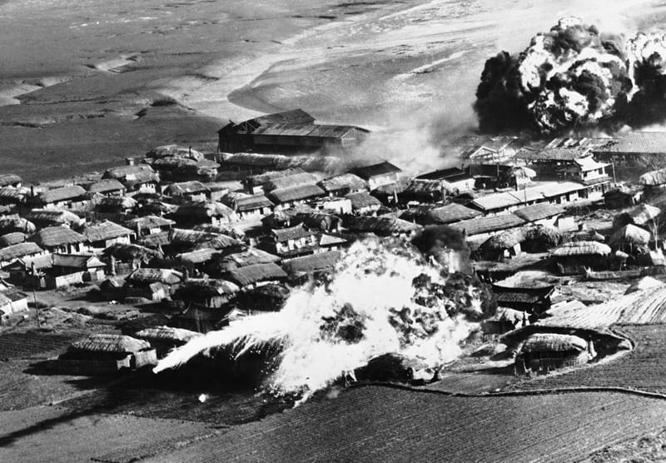
Thatched huts go up in flames after B-26 bombers unload napalm bombs on a village near Hanchon, North Korea, on May 10, 1951 (AP photo)
British journalist Reginald Thompson described “holocausts of death and jellied petroleum bombs spreading an abysmal desolation over whole communities. . . . In such warfare, the slayer merely touches a button and death is in the wings, blotting out the remote, the unknown people below.” The American investigative journalist I.F. Stone stated that sanitized reports of the air raids reflected a “gay moral imbecility utterly devoid of imagination – as if the flyers were playing in a bowling alley, with villages for pins.”[149] These comments presaged Herbert Marcuse’s 1964 book, One Dimensional Man, which warned that a cult of technical efficiency coupled with the quest for military-technological supremacy and antipathy towards foreign cultures had severed human connections and empathy in industrial capitalist societies, resulting in the kind of barbaric “machine” warfare seen in Korea and later, Vietnam.[150]
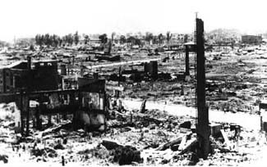
Pyongyang after U.S. bombing, 1953
Freda Kirchway, in an essay in The Nation, argued that American indifference to the destruction in Korea stemmed from the population having become “hardened by the methods of mass slaughter practiced first by Germans and Japanese and then, in self-defense, adopted and developed to the pitch of perfection at Hiroshima and Nagasaki. . . . We became accustomed to ‘area bombing,’ ‘saturation’ bombing, all the hideous forms of strategic air war aimed at wiping out not only military and industrial installations but whole populations.”[151]
As peace talks stalled in 1952, the Air Force destroyed the hydroelectric plant in Suiho that provided 90 percent of North Korea’s power supply. In blatant violation of the 1949 Geneva Convention on the Protection of Civilians in Time of War, Article 56, U.S. bombers subsequently struck three irrigation dams in Toksan, Chasan, and Kuwonga, then attacked two more in Namsi and Taechon. The effect was to unleash flooding and to disrupt the rice supply. An Air Force study concluded that “the Westerner can little conceive the awesome meaning which the loss of this staple commodity has for the Asian – starvation and slow death.” After the war it took 200,000 man days of labor to reconstruct the reservoir in Toksan alone. “Only the very fine print of the New York Times war reports mentioned the dam hits,” the historian Bruce Cumings notes, “with no commentary.”[152]

