US History Post-Amistad Discussion
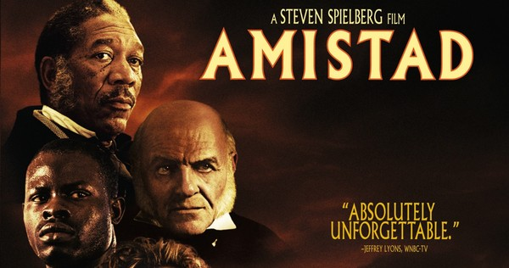
Directions: Discuss these questions in your small groups before we discuss a few of the questions in 1 large group. This is your 'final chance' for your Class Participation Grade #3…
- What are your overall reactions & thoughts to the movie Amistad?

- Even though 7 of the 9 Justices of the 1839 US Supreme Court were Southern slaveowners- and President Van Buren warned them that the symbolic act of freeing the Amistad Africans could lead to US Civil War- why do you think they voted 8 to 1 to free the Amistad Africans?

- John Quincy Adams’s speech to the Supreme Court in defense of the Amistad Africans is considered one of the greatest “US speeches” of all time. What are 5 different main ideas Adams discusses in his speech? Explain each main idea in some details!

- What did John Quincy Adams mean when he said “Who we are is who we were.” Explain!

- What does John Quincy Adams mean when he says to Cinque, “We are doing battle with a lion that is threatening to rip our country apart, and all we have on our side is a rock.” Explain!

- Some have argued that the “lion” Adams is talking about is “materialism.” In other words, there is a constant battle in the USA between the forces of “materialism” and “idealism.” Explain what this means? What are the forces of “materialism” and “idealism” in the USA?

- What does Cinque mean when he responds to Adams, “My ancestors will be on our side and help us at the judgment. I will call on them and they must come, for at this very moment, I am the only reason they have existed at all.”

- Now relate your Epic Rap Battle between Hamilton and Jefferson to questions #5,6, and 7. Explain how the rap battle between Hamilton and Jefferson does and does not fit in with questions #5-7 about a battle between materialism and idealism in the USA?

- What are at least 3 other connections you can make between the movie Amistad and the major themes in this US History class so far? Explain in details.

- I would consider the movie Amistad to be a “great work of art.” In general I try to show movies in this class that are not simply movies but are “works of art” in their own right. What does this mean? How could this movie- or any movie- be considered a “work of art”? What are some characteristics of a movie as a work of art? How do you see these characteristics in the movie Amistad?

- One characteristic of “a work of art”- whether a great movie or great book- is the incredible attention to symbolic details in the movie or book. In other words, every single scene of the movie or book (especially the ‘boring’ ones) actually contains great symbolic significance if you pay close attention. What are some examples you remember from the movie Amistad?

