US History Summer Academy 2021
Friday July 2nd FINAL CLASS DISCUSSION:
We will have one final discussion today from 10:30-11:00 am and then you are finished!- This is your last chance to raise your 10% Class Participation Grade!
Discuss the following topics in Breakout Rooms & Together as a Class:
TOPIC #1) Discuss what you wrote about in your 2nd essay for Test #4 today: What do you think are the biggest themes in USA History & give some examples of it from USA History.

TOPIC #2) Discuss again Mr. C’s favorite quote (from Susan B. Anthony). What is she saying? Do you agree or disagree? How have you seen (or not seen) this quote in US History?
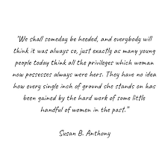
TOPIC #3) You may remember we began our first class together on the first day listening to this poem by Langston Hughes written during The Harlem Renaissance of the 1920s. We will now end our last together on the last day listening to this poem again. After we listen one last time discuss this poem with your partner. Do you agree or disagree with what he is saying? How have you seen (or not seen) the themes of this poem in USA History and present-day USA?
Let America Be America Again - YouTube

