Mr.Ciambarella US History
2nd Semester Project #1: Roaring 20's Dinner Party
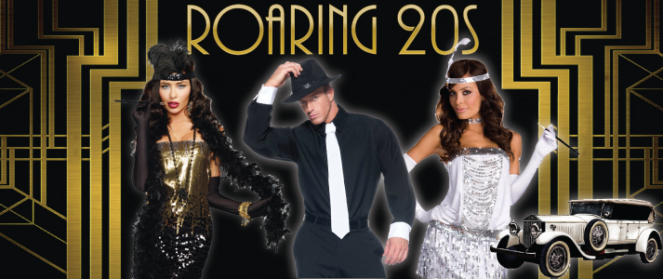 | 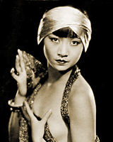
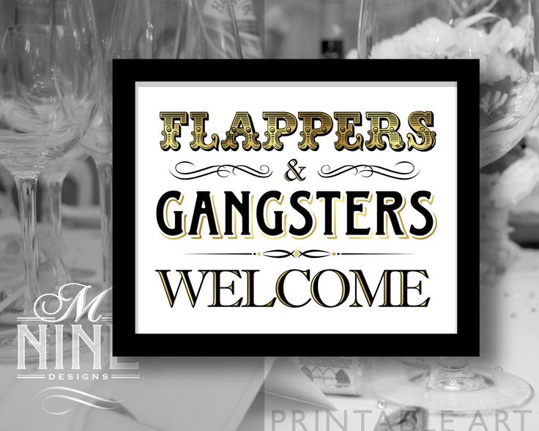 | 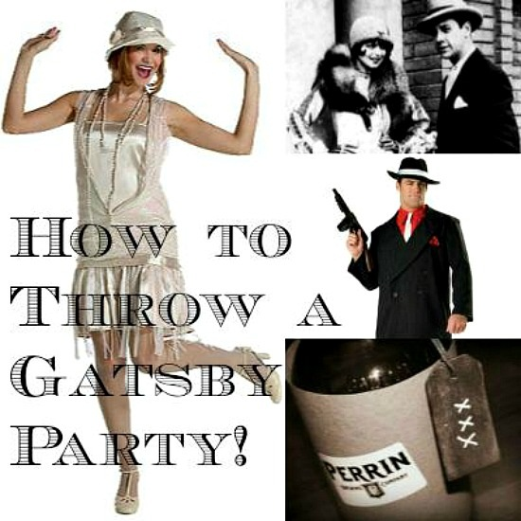

Project Grade for 30 Points
Overview: In class on 1/18 (A-Day) and 1/21 (B-Day) we will have a 30-minute 'Roaring 20s Party'. You will come to the party as your chosen character from the list below. You will mingle with different guests, learn some 1920s dances, talk about yourself & your views on several 1920s topics, and have 1 hidden agenda (such as trying to get a date with someone or maybe even trying to frame someone else)
Process:
- You will choose 1 person from the characters list below.
- You will research about this person.
- You will research and think about what this person's views on a few '1920s Conversation Topics' would be.
- You will decide on 1 hidden agenda related to 1 other character at the party.
- You will research about this hidden agenda and decide how you will carry out this plan.
- You will take some notes about all this research to turn in for part of your grade.
- On 1/18 or 1/21 we will have the 30 minute Party in Class
Party Details:
- A part of your grade is your 1 'Prop" related to your character/the roaring 20s. The 1 Prop must somehow be related to your character or to the Roaring 20's culture. You only need to do ONE of these suggestions, but can do more if you want. So choose at least ONE of these ideas:
- Dress in costume
- Wear something special
- Bring a 'prop' related to your character
- Bring some party 'snack' related to your character or roaring 20s to share
- Bring some party decorations related to your character or roaring 20s to share
- Think of some other kind of 'prop' and discuss it with Mr. C
- You must contribute to "the PARTY" by either you can give $50 NT to support the teacher buying snacks or you can bring in your own snacks to share on party day. (Make sure you NEVER carry open food or drink in the hallways! Bring it in an enclosed and covered bag!)
- The first 5-10 minutes is 'free-mingling'. You just walk around the party room, enjoy the snacks, and meet every other person in the room. For part of grade you need to introduce yourself (prepare 30 second biography of you) and make small talk to each person.
- We will learn some 1920s dances and have a dance contest for extra credit points!
- The next 10 minutes you will sit at assigned party tables where you must discuss your views on the '1920s Conversation Topics' at the end of this handout. Remember that you are always 100% in character. You do not express your personal views; you express the views of your character.
- The remaining 10 minutes you will free-mingle (maybe dance) and carry out your hidden agenda.

Roaring 1920s Character List
These are all real people from the USA "Roaring 1920s". Before the end of class today you must choose the 1 person you will be at the party.
- First, let's spend 5 minutes looking over this entire list. Make note of anyone that looks interesting to you. Try to find at least 3 or 4 possible characters.
- Now we will spend 10-15 minutes to research about some of the possible characters you chose. Surf on the internet about at least 3 different characters from this list. You do not need to take a lot of notes. But I do want you to write down some brief information (and anything that you find interesting) of these 3 people on your Project 1 Roaring 20s Homework Worksheet. (Note: if during your research you find another person not on my list then you can choose that new person if you want, as long as you get approval from Mr. C)

Here is the Character List:
Intellectuals, Writers, & Partiers
- Zelda Sayre (Fitzgerald)
American novelist; iconic figure in the 1920s; first famous flapper (per her husband's accord)
- F. Scott Fitzgerald
A novelist and chronicler of the jazz age. his wife, Zelda and he were the "couple" of the decade but hit bottom during the depression. his novel THE GREAT GATSBY is considered a masterpiece about a gangster's pursuit of an unattainable rich girl.
- Ernest Hemingway
Writer known for his simplistic stylist with great impact. A wounded WW1 veteran and member of the Lost Generation. Almost famous for his wild lifestyle from bar fights to bull fights.
- Edna St. Vincent Millay
A "bohemian" modern-woman poet who lived and wrote and partied in Greenwich Village in New York City.

Asian-Americans & African-Americans
- Anna May Wong
The first Chinese-American movie star
- Josephine Baker
The "Beyonce" of the 1920s- the first great African-American movie star.
- Duke Ellington
Born in Chicago middle class. moved to Harlem in 1923 and began playing at the cotton club. Composer, pianist and band leader. Most influential figures in jazz.
- Marcus Garvey
African American leader during the 1920s who founded the Universal Negro Improvement Association and advocated mass migration of African Americans back to Africa. Was deported to Jamaica in 1927.
- Bessie Smith
Sometimes referred to as The Empress of the Blues, she was the most popular female blues singer of the 1920s and 1930s.Along with Louis Armstrong, she had a major influence on subsequent jazz vocalists.
- George Washington Carver
African American farmer and food scientist. His research improved farming in the South by developing new products using peanuts; taught and researched at the Tuskegee Institute
- Langston Hughes
African American poet who described the rich culture of African American life using rhythms influenced by jazz music. He wrote of African American hope and defiance, as well as the culture of Harlem and also had a major impact on the Harlem Renaissance.
- Zora Neal Hurston
An important Harlem Renaissance writer whose masterpiece was Their Eyes Were Watching God. Her writing was very regional and closely followed the speech patterns of central Florida., A playwright during the Harlem Renaissance, she wrote "Color Struck".

Feminist & Women Icons
- Margret Sanger
American leader of the movement to legalize birth control during the early 1900's. As a nurse in the poor sections of New York City, she had seen the suffering caused by unwanted pregnancy. Founded the first birth control clinic in the U.S. and the American Birth Control League, which later became Planned Parenthood.
- Coco Chanel
First designer to make pants for women. popularized boyish style for women. Forefront of France fashion after WWI. Thanks to her, tans suddenly became associated with the leisure activities of the rich and famous such as long cruises, island vacations, and other sunny pursuits.
- Jeanette Rankin
First woman to serve in Congress. Suffragist and pacifist, voted against US involvement in WWI and WWII.
- Alice Paul
head of the National Woman's party that campaigned for an equal rights amendment to the Constitution. She opposed legislation protecting women workers because such laws implied women's inferiority. Most condemned her way of thinking.
- Amy Semple McPherson
Used modern methods to get a traditional idea across. Came out of Pentecostal tradition and set up church in L.A. Developed flamboyant style, used radio.

Gangsters, Outlaws, & Criminals
- Al Capone
A leader of organized crime in Chicago in the late 1920s, involved in gambling, the illegal sale of alcohol, and prostitution. He was sent to prison in the 1930s for income tax evasion.
2 and 3. Need a "couple" to play Bonnie & Clyde
Female- "Bonnie" (Bonnie Elizabeth Parker)
Male- "Clyde" (Clyde Chestnut Barrow)
The famous outlaw couple of the 20s and 30s who travelled the USA and staged a series of famous robberies and other crime schemes.
- John Dillinger
Maybe the most famous outlaw of the 20s- and recently played by Johnny Depp in the movie about his famous crime-spree across the USA
- Owney Madden
The famous owner (and musician at) of The Cotton Club
- Stephanie St. Clair (Madame St. Clair)
A famous African-American "outlaw" who was one of the leaders of the Cotton Club in Harlem, New York
- Ma Barker
Sometimes known as the "Godmother" of organized crime in the roaring 20s.
- Or someone can play the creator of the modern FBI who tried to catch these gangsters….. J. Edgar Hoover
The first Director of the Federal Bureau of Investigation (FBI) of the United States. He founded the present form of the agency, and remained director for 48 years until his death. During his life, Hoover was highly regarded by much of the U.S. public. Hoover's leadership spanned eight presidential administrations, encompassed Prohibition, the Great Depression, World War II, the Korean War, the Cold War, and the Vietnam War. During this time, the United States moved from being a rural nation with strong isolationist tendencies to an urbanized superpower.

Intellectuals, Artists, and Scientists
- Albert Einstein
German born theoretical physicist. Best known for his theory of relativity and his theory of energy equivalence. Received Nobel Prize in 1921 for physics.
- Georgia O'Keefe
Chiefly known for paintings in which she synthesized abstraction and representation in paintings of flowers, rocks, shells, animal bones and landscapes. Her paintings present crisply contoured forms that are replete with subtle tonal transitions of varying colors. She often transformed her subject matter into powerful abstract images.
- Clarence Darrow
A famed criminal defense lawyer for Scopes, who supported evolution. He caused William Jennings Bryan to appear foolish when Darrow questioned Bryan about the Bible.
- Walt Disney
Film maker, cartoonist, visionary. He opened small animation studio in 1923 and created a worldwide media empire, brought families and countries together. He developed many famous characters as well as amusement theme parks.
- Al Jolson
A Jewish Lithuanian Immigrant and Vaudeville Performer: He was the star of the first motion picture with sound, "The Jazz Singer."
- Norman Rockwell
A twentieth-century American artist and illustrator, known for his warm-hearted paintings of rural and small-town life in the united States. Many of his paintings appeared cover illustrations for the magazine The Saturday Evening Post.
Socialists, Anarchists, and other "Radicals"
- Eugene V. Debs
Labor leader arrested during the Pullman Strike (1894); a convert to socialism, Debs ran for president five times between 1900 and 1920. In 1920, he campaigned from prison where he was being held for opposition to American involvement in World War I.
- Nicola Sacco
United States anarchist (born in Italy) who with Bartolomeo Vanzetti was convicted of murder and in spite of world-wide protest was executed (1891-1927). Was said to have robbed a shoe factory and murder a clerk and another worker.
- Tina Modotti
An Italian-American actress and photographer who travelled the world and often worked as a "spy" for socialist and communist movements.

Some other Famous People
- Charles Lindbergh
Known as "Lucky Lindy" and "The Lone Eagle," was an American pilot famous for the first solo, non-stop flight from New York to Paris in 1927 in the Spirit of St. Louis. In the ensuing deluge of notoriety, he became the world's best-known aviator.
- Henry Ford
American businessman, founder of Ford Motor Company, father of modern assembly lines, and inventor credited with 161 patents.
- Babe Ruth
The greatest baseball player of the 1920's. He set a record for hitting 60 home runs in one season.
- Woodrow Wilson
28th president of the United States, known for World War I leadership, created Federal Reserve, Federal Trade Commission, Clayton Antitrust Act, progressive income tax, lower tariffs, women's suffrage (reluctantly), Treaty of Versailles, sought 14 points post-war plan, League of Nations (but failed to win U.S. ratification), won Nobel Peace Prize.

1920s Conversation Topics (The Americans textbook pages)
- Topic #1: American prosperity & American consumer culture (page 631 vs page 657)
-Has the Industrial Revolution finally created 'the modern age' where Americans can enjoy all of modernity's prosperity- a nice house, a television and radio, a washing machine, a car. "The American Dream" is all about having a family, getting a good-paying job, and buying all the modern products available.
-Or has this "modernity" and consumer culture destroyed what is great about America and destroyed our humanity. We have sold away our freedom, democracy, and individuality for "a fake American dream" all about buying the same products. In fact we are a "Lost Generation" with no other purpose than to buy products.
-Or another view on this topic?

- Topic #2: The American Melting Pot & Red Scare (pages 619-621)
-The USA is becoming a 'melting pot' where immigrants from all over the world come to the USA to make the USA a greater country.
-Or immigrants are destroying "America's culture" especially those bringing dangerous ideas, such as communism and socialism.

- Topic #3: The Changing Woman & Changing Family (pages 646-649)
-Young women are finally starting to live lives of more freedom and equality. They can start to dress as they please and get different kinds of jobs outside of the home.
-This is destroying the "American family'. Girls and women are destroying themselves and the family with this reckless and lewd attitude and behavior.

- Topic #4: Religion vs. Science (pages 644-645)
-The USA is a great, religious nation founded on the Bible and Christianity. It must continue to make these "Fundamentalist" beliefs the center of American culture and education.
-The USA must change its religious past and be a world leader in the education and advancement of science, such as teaching the new theory of evolution.

- Topic #5 Crime & Prohibition (pages 642-643)
-One thing that is destroying the USA is alcohol and crime. The USA must make it a top priority to make alcohol illegal (called "Prohibition") and fighting crime and having tough penalties for criminals.
-One thing that always made the USA great was individual freedom. The freedom to drink alcohol- and the freedom to do most anything- should never be taken away.
-Many 'criminals' are not really criminals- but rather 'freedom fighters' fighting for American individual freedom.

- Topic #6 American Isolationism vs. Intervention (page 618)
-World War I has signaled to the world the rise of the USA as the new world power. The USA must continue to be the leader of all international world affairs.
-World War I proved George Washington's advice was right: the USA should stay isolated and neutral & should not get involved in Europe and the world's constant bloody and terrible wars.

- Topic #7 Big Business vs. Labor (page 628 vs. page 623)
-As President Coolidge famously said "The chief business of the American people is business". In other words what makes the USA great is big business. Big Business and its needs should always remain the #1 concern.
-Big business does not care for the USA or Americans; it only cares about making money for itself. The USA must continue to attack big business and support workers and labor strikes.

