Mr. Ciambarella US History 2022
PROJECT #2: Rap Battle: Hamilton vs. Jefferson
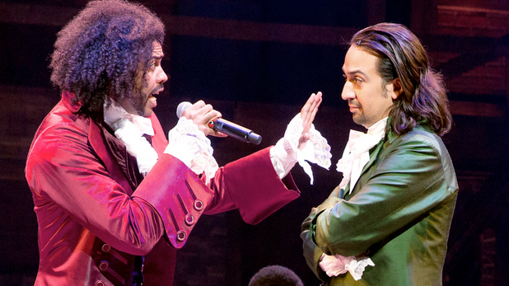
80 Points for Project Grade
The finalized Rap is DUE on 10/7 for A-Day and 10/12 for B-Day
Overview:
You will write & then record or perform a rap battle between Alexander Hamilton and Thomas Jefferson
For an example from last year's class go to my website (www.mrciambarellaclass.com) Then click on "Hall of Fame" at the top.
Then click on "Click HERE to see Student Videos"
Then click on Videos
You can either work by yourself and you need to rap for BOTH Hamilton and Jefferson. Or you can work with a partner (so one of you raps for Hamilton and one of you raps for Jefferson) I prefer you work with a partner!
You have to type out/write out the lyrics for your rap and upload your lyrics to Canvas. Make sure you tell me which lyrics you wrote & which lyrics your partner wrote!
You have the choice to EITHER perform your rap to the class OR privately record your rap and share it only with me.
The lyrics you write are worth 50 points.
Your performance or recording is worth 30 points.
SPECIAL NOTE: If you do decide to perform your rap live to the class then you get the automatic 30/30 performance points no matter what!
How to get a good grade?
- Content- you must discuss many main ideas in the debate between Hamilton and Jefferson. Make sure you use 'KEY HISTORY VOCABULARY WORDS' in your rap. (So use main ideas & key words from our textbook…such as 'Federalists', 'Democratic-Republicans', 'strict interpretation of Constitution', 'broad interpretation of Constitution', etc.)
- Evidence- try to use some real 'history evidence' and 'examples' about what Hamilton and Jefferson are debating about (so use examples from our textbook, such as 'Bank of United States', 'French Revolution', 'Whiskey Rebellion' ,etc.)
- Creativity- make your rap creative!
You need 'history' stuff- but you should also have a creative rap that rhymes too!

- You need some sort of "PERFORMANCE" of your rap for 30 out of 80 points.
Here are some options.
- You could do a live performance of your rap to the class on the due date! This is the fastest and most-assured way to get a full 30/30 points! Provide and play your own music.

- Use a 'professional-rap-APP' to put some music to your lyrics. There are many APPS that can do this. Two of my favorites are called
“Smule autorap” and 'Rapchat'.
With these apps you can easily add background music to your lyrics and easily record your rap on their app. Then you can use this app to email me your finalized rap.
-So you can use Smule autorap, Rapchat or another APP to record your rap and then email it to me before class on the due date.

- If you know how, you can add your own music to your rap and record it and send to me.

- You could make a youtube video like the one I showed you in class today.

