Vietnam War Protest Songs
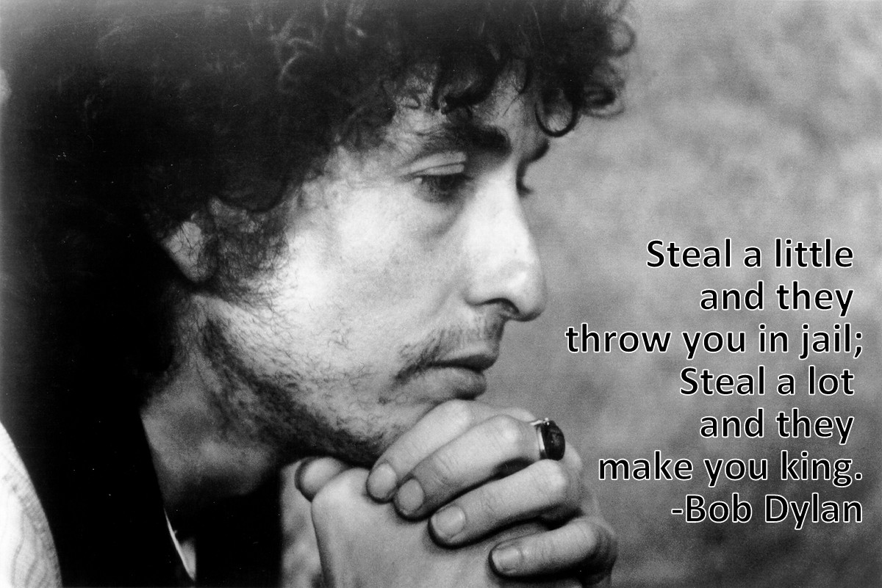
- Bob Dylan “All Along the Watchtower” (performed by Jimi Hendrix)
"There must be some kind of way out of here, "
Said the joker to the thief,
"There's too much confusion, I can't get no relief.
Business men – they drink my wine
Plowmen dig my earth
None of them along the line
Know what any of it is worth."

"No reason to get excited, "
The thief – he kindly spoke,
"There are many here among us
Who feel that life is but a joke
But you and I we've been through that
And this is not our fate
So let us not talk falsely now
The hour's getting late."

All along the watchtower
Princess kept their view
While all the women came and went
Bare-foot servants too
Outside in the cold distance
A wild cat did growl
Two riders were approaching
And the wind began to howl, hey.

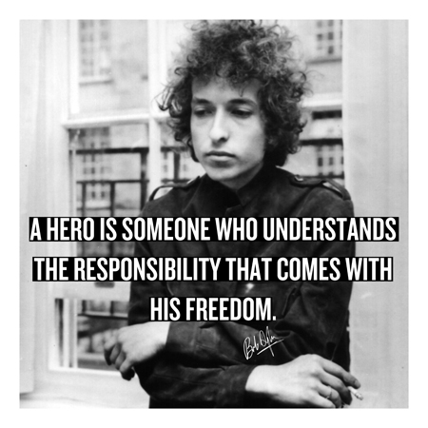
- Bob Dylan “Hard Rain’s Gonna Fall”
Oh, where have you been, my blue-eyed son ?
And where have you been my darling young one ?
I've stumbled on the side of twelve misty mountains
I've walked and I've crawled on six crooked highways
I've stepped in the middle of seven sad forests
I've been out in front of a dozen dead oceans
I've been ten thousand miles in the mouth of a graveyard
And it's a hard, it's a hard, it's a hard, and it's a hard
It's a hard rain's a-gonna fall.

Oh, what did you see, my blue eyed son ?
And what did you see, my darling young one ?
I saw a newborn baby with wild wolves all around it
I saw a highway of diamonds with nobody on it
I saw a black branch with blood that kept drippin'
I saw a room full of men with their hammers a-bleedin'
I saw a white ladder all covered with water
I saw ten thousand talkers whose tongues were all broken
I saw guns and sharp swords in the hands of young children
And it's a hard, it's a hard, it's a hard, and it's a hard
It's a hard rain's a-gonna fall.

And what did you hear, my blue-eyed son ?
And what did you hear, my darling young one ?
I heard the sound of a thunder, it roared out a warnin'
I heard the roar of a wave that could drown the whole world
I heard one hundred drummers whose hands were a-blazin'
I heard ten thousand whisperin' and nobody listenin'
I heard one person starve, I heard many people laughin'
Heard the song of a poet who died in the gutter
Heard the sound of a clown who cried in the alley
And it's a hard, it's a hard, it's a hard, it's a hard
And it's a hard rain's a-gonna fall.

Oh, who did you meet my blue-eyed son ?
Who did you meet, my darling young one ?
I met a young child beside a dead pony
I met a white man who walked a black dog
I met a young woman whose body was burning
I met a young girl, she gave me a rainbow
I met one man who was wounded in love
I met another man who was wounded in hatred
And it's a hard, it's a hard, it's a hard, it's a hard
And it's a hard rain's a-gonna fall.

And what'll you do now, my blue-eyed son ?
And what'll you do now my darling young one ?
I'm a-goin' back out 'fore the rain starts a-fallin'
I'll walk to the deepths of the deepest black forest
Where the people are a many and their hands are all empty
Where the pellets of poison are flooding their waters
Where the home in the valley meets the damp dirty prison
Where the executioner's face is always well hidden
Where hunger is ugly, where souls are forgotten
Where black is the color, where none is the number
And I'll tell and think it and speak it and breathe it
And reflect it from the mountain so all souls can see it
Then I'll stand on the ocean until I start sinkin'
But I'll know my songs well before I start singin'
And it's a hard, it's a hard, it's a hard, and it's a hard
It's a hard rain's a-gonna fall.
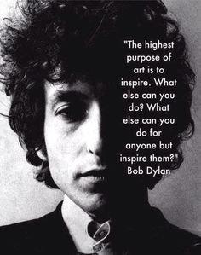
- Bob Dylan “Masters of War”
Come you masters of war
You that build all the guns
You that build the death planes
You that build all the bombs
You that hide behind walls
You that hide behind desks
I just want you to know
I can see through your masks.

You that never done nothin'
But build to destroy
You play with my world
Like it's your little toy
You put a gun in my hand
And you hide from my eyes
And you turn and run farther
When the fast bullets fly.

Like Judas of old
You lie and deceive
A world war can be won
You want me to believe
But I see through your eyes
And I see through your brain
Like I see through the water
That runs down my drain.

You fasten all the triggers
For the others to fire
Then you set back and watch
When the death count gets higher
You hide in your mansion'
As young people's blood
Flows out of their bodies
And is buried in the mud.

You've thrown the worst fear
That can ever be hurled
Fear to bring children
Into the world
For threatening my baby
Unborn and unnamed
You ain't worth the blood
That runs in your veins.

How much do I know
To talk out of turn
You might say that I'm young
You might say I'm unlearned
But there's one thing I know
Though I'm younger than you
That even Jesus would never
Forgive what you do.

Let me ask you one question
Is your money that good
Will it buy you forgiveness
Do you think that it could
I think you will find
When your death takes its toll
All the money you made
Will never buy back your soul.

And I hope that you die
And your death'll come soon
I will follow your casket
In the pale afternoon
And I'll watch while you're lowered
Down to your deathbed
And I'll stand over your grave
'Til I'm sure that you're dead.

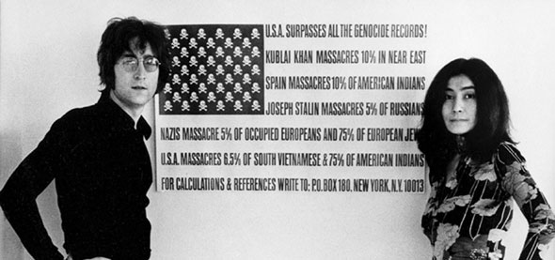
- John Lennon “Imagine”
Imagine there's no heaven
It's easy if you try
No hell below us
Above us only sky
Imagine all the people
Living for today...
Imagine there's no countries
It isn't hard to do
Nothing to kill or die for
And no religion too
Imagine all the people
Living life in peace...
You may say I'm a dreamer
But I'm not the only one
I hope someday you'll join us
And the world will be as one
Imagine no possessions
I wonder if you can
No need for greed or hunger
A brotherhood of man
Imagine all the people
Sharing all the world...
You may say I'm a dreamer
But I'm not the only one
I hope someday you'll join us
And the world will live as one

