Taipei American School: World Religions 2018-2019

Teacher: Mr. Chris Ciambarella
Email: ciambarellac@tas.tw
Class Website: www.mrciambarellaclass.com

COURSE OVERVIEW

This class begins and ends with humanity’s big questions: 1)Why are you here?; 2)Is there a God?; 3)What happens after death?; 4)What does it mean to be human?; 5) How do you live the best human life? During the course of this year we will explore together how different World Religions, Cultures, & Philosophies have answered these questions. A major theme of this class is to also explore if there are different “ways of knowing” the answers to these big questions through the use of different faculties: reason, emotion, faith, imagination, intuition, language, memory, and experience. The goal of this course is to assist students in the exploration of these questions by looking at how different religions, cultures, and ways of knowing have approached them. As such we will not only read about religious ideas but also experience them through doing such activities as yoga, meditation, and hopefully field trips and guest speakers.
For this second semester, we will continue our study of the "World's Major Religions" by focusing on Judaism, Christianity, and Islam. However, we will also explore Native American, Aboriginal, and Goddess Religious Systems as well. Finally, much of the second semester is devoted to your own independent projects and an end-of-the-year symposium reflecting and discussing the entire year's study and work.
SECOND SEMESTER PLAN
Unit 1: Independent Projects Unit 2: Native American, Aboriginal & Goddess Religions
Unit 3: Judaism & Christianity Unit 4: Islam
Unit 5: End of Year Symposium

2nd Semester Grading

30% Independent Project
30% Socratic Seminars
20% Homework & Portfolio
20% Class Participation

CLASS MATERIALS

- As explained in the 1st Semester you must have 2 teacher-approved academic BOOKS for your Independent Topic. You must be able to read these books during every class (on your computer or print books)

- We will continue to use our 1 "textbook"- Huston Smith's Illustrated World's Religions

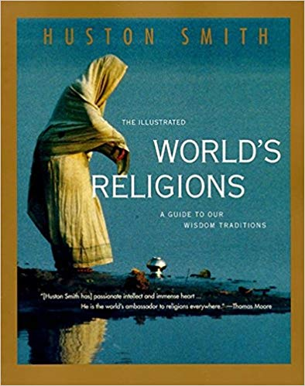 | Title: The Illustrated World's Religions  Author: Huston Smith  Paperback: 256 pages  Publisher: HarperOne; 1st HarperCollins Pbk. Ed edition (August 18, 1995)  Language: English  ISBN-10: 0060674407  ISBN-13: 978-0060674403

- We will be reading a lot from this book- Lucy Pearce Burning Woman
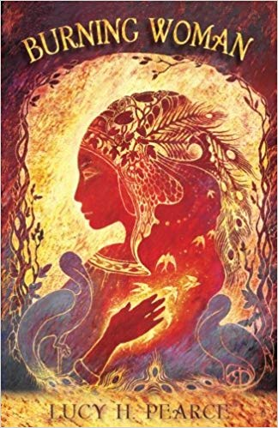 | Title: Burning Woman  Author: Lucy Pearce  - Paperback: 288 pages  - Publisher: Womancraft Publishing (April 26, 2016)  - Language: English  - ISBN-10: 1910559164  - ISBN-13: 978-1910559161

CLASS POLICIES

- On the day of a Socratic Seminar you MUST participate. You cannot ask for an extension on a Socratic Seminar. If you are present in class then you must take part in the seminar.
- Exceptions to this rule can only be made for Official School Trips/Activities Extensions (IASAS, MUN, etc.) where the student emails me for an extension at least 3 days before the Seminar.
- Exceptions can also be made for students that are sick ONLY if the students emails me a request for extension at least 24 hours in advance.
- If you are given permission for an extension of a class Seminar or Activity then usually you must meet with me individually during free time to make up the seminar or activity.

