Mr. C US History
2nd Semester 2020
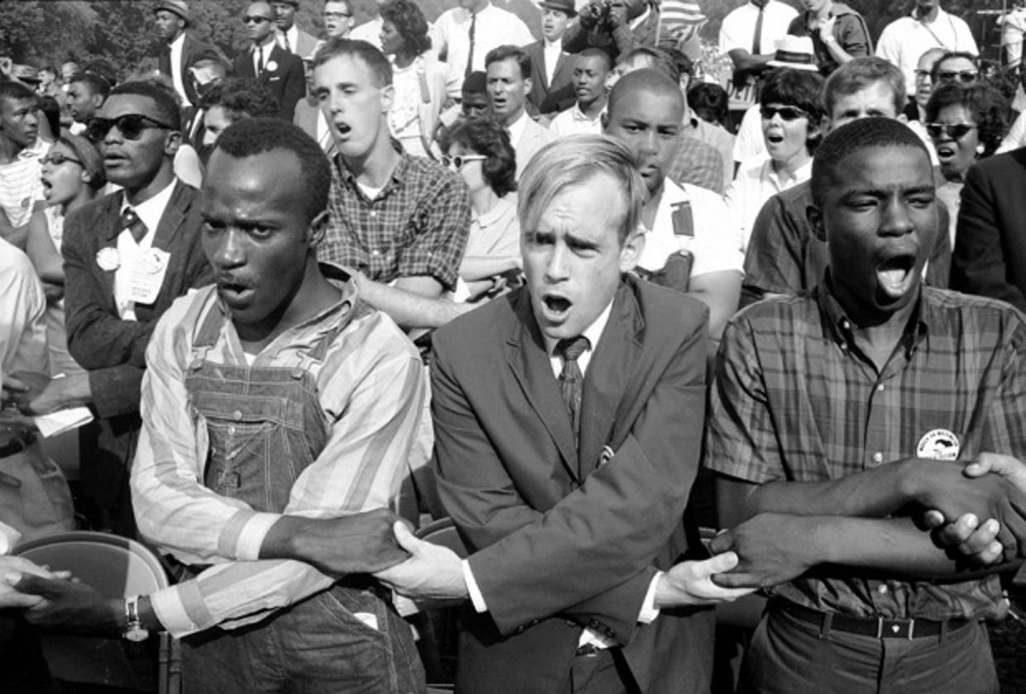 | 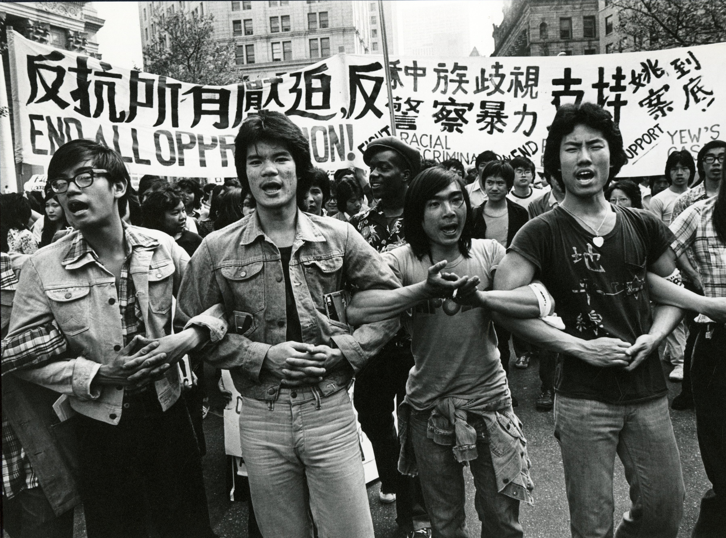

Welcome back! If you found US History in the 1st Semester interesting and important- which I hope you did- then be excited because 2nd Semester is even more interesting, important, and fun. These 2nd Semester Topics are my favorite and why I love to be a teacher. I'll even go so far to say that learning about topics such as the role of the students in the pictures above here in the 1960s US Civil Rights Movement may even be life-changing. I know it was for me. More than ever I hope you will see how these 2nd Semester topics relate directly to you and the kind of country and world you want to live in- and the important role you play in this story.

Brief Overview & Major Topics Covered:
Unit 5 WWI to the Great Depression
Unit 6 WWII to The Cold War
Unit 7 The Civil Rights Movements & 60s Protest/Counterculture
Unit 8 The Vietnam War to the War in Iraq
Unit 9 Group Project & Modern US History

2nd Semester Grade Breakdown:
15% Semester Final Exam
20% Homework & Participation
30% Tests & Quizzes
We have 3 Unit Tests (Unit 5, Unit 6, and Unit 8)
There is no Unit 7 or Unit 9 Test (only a Project for Unit 7 and 9)
15% Projects
We have 4 Projects
- Roaring 20's Dinner & Dance Party
- Debate on US dropping atomic bomb on Japan
- A Trial of Malcolm X
- A Final Group Project on Modern USA
20% Research Paper
You should already have most all your sources ready to read.
You will read and take notes on your sources…
You will make an outline of your paper…
You will write a rough draft….
And you will write a final draft

Two Final Thoughts about the 2nd Semester:

- Why are we doing this?
Answer: this is college-prep.
-The majority of your social sciences college classes your first 2 years of college have the same requirements for your grade: A Midterm and Final Exam & 1 Research Paper.
-This largely determines your entire grade for college! College classes assume that you already know how to do well on these: 1)You already know how to learn material by yourself and do well on a midterm and final exam. Most of your midterm and final exam involves writing long essays, and 2) You already know how to write an advanced research paper by yourself.

- College-Recommendation Letters
I wrote over 50 college recommendation letters this year for students who took my US History class. Do you know what I did NOT write about in these letters? I did NOT write about your test scores or grades.
Do you know what I DID write about?
- I wrote about your attitude in class. Do you pay attention in class? Do you participate in class discussions? Do you answer questions? Are you excited to come to class and talk about US History?
- I wrote about your Projects. Did you get excited about any projects this year? Did you do something creative and interesting? Did you show real passion and excitement for your projects?
- I wrote about your Research Paper. Did you get excited about your research paper? Did your research paper reveal your passion and excitement for learning, studying, and scholarship.

Of course, colleges want to know that you got good grades on tests; however, more important is colleges want to know about your excitement and attitude towards learning and how you demonstrate that passion in your projects and papers.

VERY IMPORTANT CLASS CHANGES and POLICIES

- PLAGIARISM
Plagiarism will be dealt with very seriously!
All the work for this class must be entirely your own.
If you ever copy any work from another source or another student you MUST CLEARLY state and cite this.
You should NEVER copy another student's work in this class. I repeat- you should never copy another's student's homework and submit it as your own.
For the research paper if you ever copy words or ideas from another source you MUST ALWAYS CITE THE SOURCE. Whether it is a direct quotation or a paraphrase you must always cite where you got the information from!

Any suspicions of plagiarism or copying will be sent directly to the Upper School Administration and there will be serious consequences.

- MISSING AND LATE HOMEWORK
There is a new policy for late homework that will be followed closely
Any homework that is 1 day late can only get a maximum score of 90%
Any homework that is 1 week late can only get a maximum score of 80%
Any homework that is 2 weeks late can only get a maximum score of 70%
Any homework that is over 2 weeks late can only get a maximum score of 60%

You only get an extension on homework is you are Officially Absent from School, on an official school trip away from school, or if you get approval from me at least 24 hours before the assignment is due.

- TURNING in HOMEWORK
Starting this second semester all homework (except for your Research Notetracking Sheet) will be submitted via Canvas directly.
DO NOT put any homework in your google homework folder any more. Just submit all homework through Canvas.
The only thing that you should still keep in your google homework folder is your Research Notetracking Sheet.

