Primary Documents on 1st Semester Final Exam
Document 1
"The women are unhappy with this form of government because there is taxation without representation. They are also unhappy because they are forced to obey laws that they never agreed to. The women also dislike this form of government because they can be imprisoned or hung without a trial by a jury of their peers. In addition, their husbands can take their money, and they don’t have the right to make decisions about themselves, their money, and their children.
Women are half of all people, but the other half (men) has all the power. This goes directly against both the words and the ideas of the founding fathers, who based all their declarations on the concept of equal rights for all people." ~ Susan B. Anthony, "Is it a Crime for a Citizen of the United States to Vote?", 1872.

Document 2
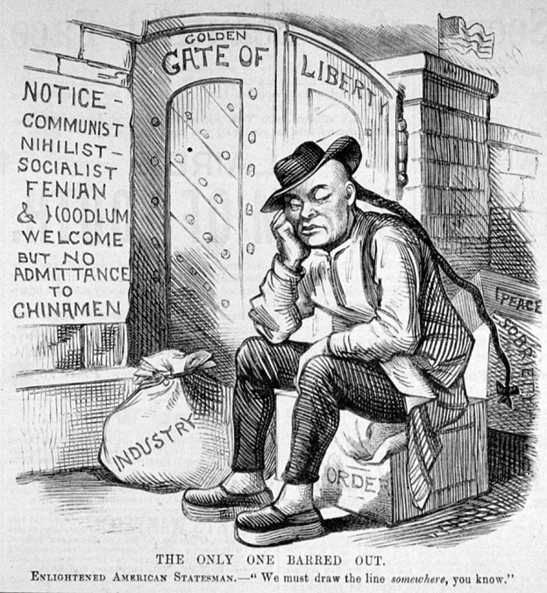
"The Only One Barred Out," Frank Leslie, New York, 1882.

Document 3

"The old nations of the earth creep on at a snail’s pace; the Republic thunders past with the rush of the express. The United States, the growth of a single century, has already reached the foremost rank among nations, and is destined soon to out-distance all others in the race. In population, in wealth, in annual savings, and in public credit; in freedom from debt, in agriculture, and in manufactures, America already leads the civilized world.
The causes which have led to the rapid growth and aggrandizement of this latest addition to the family of nations constitute one of the most interesting problems in the social history of mankind. What has brought about such stupendous results — so unparalleled a development of a nation within so ethnic character of the people, the topographical and climatic conditions under which they developed, and the influence of political institutions founded upon the equality of the citizen.~Andrew Carnegie, Triumphant Democracy: Or, Fifty Years’ March of the Republic, New York, 1886,

Document 4
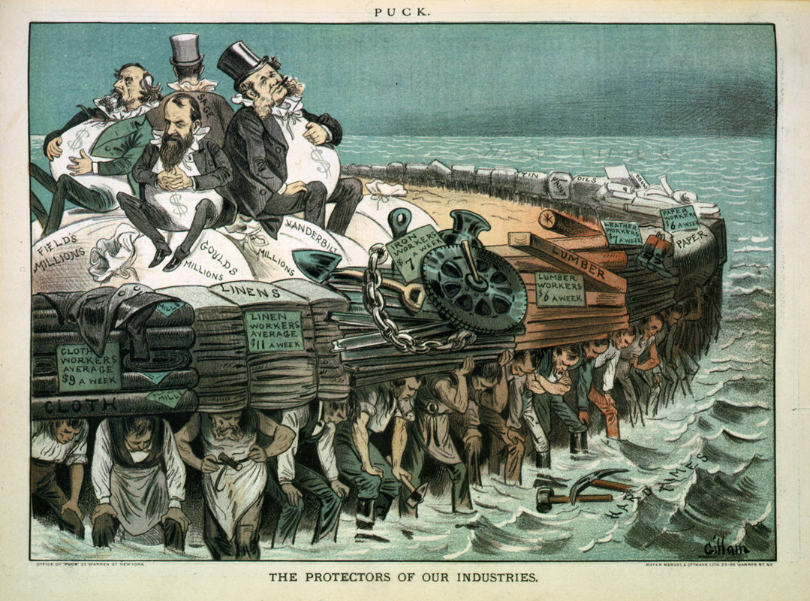
“The Protector of our Industries”- Political cartoon in Puck Magazine . February 7, 1883

Document 5

"I, LILIUOKALANI, by the grace of God and under the Constitution of the Hawaiian
Kingdom, Queen, do hereby solemnly protest against any and all acts done against myself and the Constitutional Government of the Hawaiian Kingdom by certain persons claiming to have
established a provisional government of and for this Kingdom.

That I yield to the superior force or the United States or America, whose minister plenipotentiary, His Excellency John L. Stevens, has caused United States troops to be landed at Honolulu and declared that he would support the said provisional government.
How to avoid any collision of armed forces and perhaps the loss of life, I do, under this protest,
and impelled by said force, yield my authority until such time as the Government of the United
States shall upon the facts being presorted to it undo the action of its representatives and reinstate
me in the authority which I claim as the constitutional sovereign of the Hawaiian Kingdom." ~ Hawaiian Resolution and Protest against Annexation, Queen Liliuokalani, January 16, 1893.

Document 6

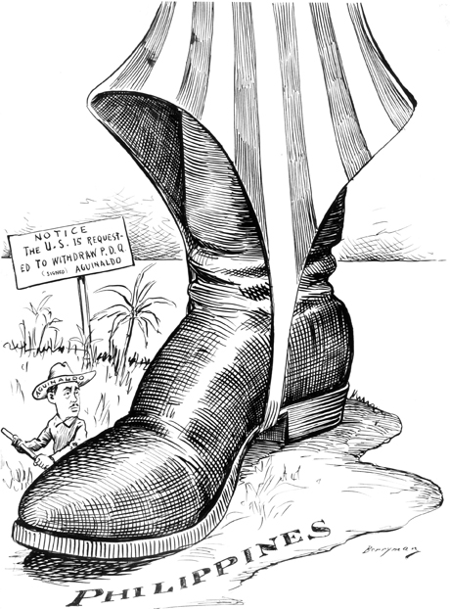
Clifford Berryman untitled cartoon in The Washington Post. February 4, 1899

