Primary Documents on the Unit 1 Test
-All 6 of the following Primary Documents will be given to you when you take the Unit 1 Test
Remember in order to get an “A” on your Essay you must use 1 of the following primary documents somewhere in your essay answer.

Primary Document #1: The Mayflower Compact- 1620
In the name of God, Amen. We whose names are under-written, the loyal subjects of our dread sovereign Lord, King James, by the grace of God, of Great Britain, France, and Ireland King, Defender of the Faith, etc. Having undertaken, for the glory of God, and advancement of the Christian faith, and honor of our King and Country, a voyage to plant the first colony in the northern parts of Virginia, do by these presents solemnly and mutually, in the presence of God, and one of another, covenant and combine our selves together into a civil body politic, for our better ordering and preservation and furtherance of the ends aforesaid; and by virtue hereof to enact, constitute, and frame such just and equal laws, ordinances, acts, constitutions and offices, from time to time, as shall be thought most meet and convenient for the general good of the Colony, unto which we promise all due submission and obedience. In witness whereof we have hereunder subscribed our names at Cape Cod, the eleventh of November [New Style, November 21], in the year of the reign of our sovereign lord, King James, of England, France, and Ireland, the eighteenth, and of Scotland the fifty-fourth. Anno Dom. 1620.

Primary Document #2: Drawing from Diary of Bartolome de Las Casas, 1522
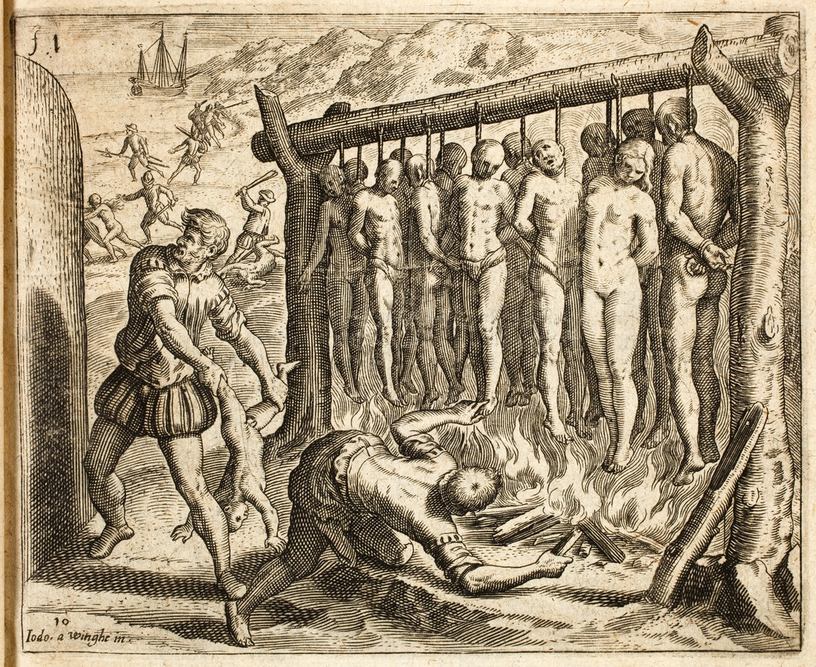
Primary Document #3: Ad from Charles Town, South Carolina- 1769
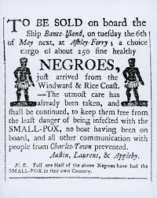 | Here is the script of the poster:  "To be sold on board the Ship Bance Island, on Tuesday the 6th of May next, at Ashley-Ferry, a choice cargo of about 250 fine healthy Negroes, just arrived from the Windward & Rice Coast.  -The utmost care has already been taken, and shall be continued, to keep them free from the least danger of being infected with the SMALL-POX, no boat having been on board, and all other communication with people from Charles-Town prevented.  Austin, Laurens, & Appleby  N.B. Full One Half of the above Negroes have had the SMALL-POX in their own country.

Primary Document #4: William Penn Letter to the 'Colonial Society of Free Traders' speaking about the Native Americans in Delaware called the Leni-Lenape- 1683
"But in Liberality they excel; nothing is too good for their friend. Give them a fine Gun, Coat, or other thing, it may pass twenty hands before it sticks. Light of Heart, strong Affections, but soon spent; the most merry Creatures that live, Feast and dance perpetually. They never have much nor want much. Wealth circulate like the Blood, all parts partake; and though none shall want what another hath, yet exact Observers of Property.. . They care for little, because they want but little; and the Reason is, a little contents them. In this they are sufficiently revenged on us; if they are ignorant of our Pleasures, they are also free from our Pains. They are not disquieted with Bills of Lading and Exchange, nor perplexed with Chancery-Suites and Exchequer Reckonings. We sweat and toil to live; their pleasure feeds them, I mean, their Hunting, Fishing and Fowling, and this Table is spread everywhere; they eat twice a day, Morning and Evening; their Seats and Table are the Ground."

Primary Document #5: The Declaration of Independence- July 4, 1776
"We hold these truths to be self-evident, that all men are created equal, that they are endowed by their Creator with certain unalienable Rights, that among these are Life, Liberty and the pursuit of Happiness. — That to secure these rights, Governments are instituted among Men, deriving their just powers from the consent of the governed, — That whenever any Form of Government becomes destructive of these ends, it is the Right of the People to alter or to abolish it, and to institute new Government, laying its foundation on such principles and organizing its powers in such form, as to them shall seem most likely to effect their Safety and Happiness....And for the support of this Declaration, with a firm reliance on the protection of Divine Providence, we mutually pledge to each other our Lives, our Fortunes, and our Sacred Honor."

Primary Document #6: "The Boston Massacre" by Paul Revere-March 5, 1770

