US History Research Note Tracking Sheet
Your Name:
Your Topic: How have government initiatives affect criminal justice for Native Americans throughout history?
Directions- Every time you read anything related to your research paper you must do 'note-tracking' on this sheet. This Notetracking Sheet is worth 40 out of the 155 points for the 20% 'Research Paper Grade' this semester. Keep this Sheet in your research paper subfolder in your Google Homework folder & keep adding notes to this same sheet as you go along in the semester.
If you do a good job taking notes and writing down paraphrases and quotations here, then you can use them in your actual research paper.
Date & Specific Time  i.e.  1/9 9:30-10:30 am | Source & Specific Pages Read  i.e.  Pearce Burning Woman pages 3-21 | Notes from this Specific Reading  -You can simply write a summary at the end of your reading…and/or  -You can copy some "specific quotations" and page numbers….and/or  -You can paraphrase with some "quotations" and page numbers…and/or  -You can take some notes as you read
⅙ 2:25- 2:53pm | Bachman, Ronet  Primary | Pg. 31 rape & sexual assault [pages read 31-38]  - National Crime Victimization Survey (NCVS “monitors rape and sexual assault on an annual basis”) - data is from 1992 - 2005, victims of 12+-year-olds  - 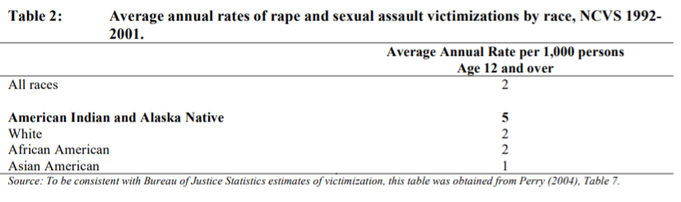  - Out of the racial group of A.I ( American Indians) and A.N’s (Alaska Natives) 87% were female victims and 13% were male victims of the 6,956 annual average number  - This racial group had a higher likely result in a completed rape than the other women  - Victims have been injured by gunshot, broken bone, stab wounds, chipped teeth, internal injuries, bruising, cuts & swelling - 91% victim was hit  - Often being from someone they know  Pg 58 Stalking [pages read 58-60]  - 17% of Al.N & A.I women were stalked  - They had more fear  Pg 67 The Criminal justice systems response to violence against American Indian and Alaska Native women  - Boarding schools were removed  - Indian Reorganization Act of 1934  - Stripped power from AI families, community & spiritual leaders in tribal justice systems  - HISTORICAL VICTIMIZATION
⅙ 3:00- 3:13pm | Whole article  (Primary)  Golden, Hallie.  Missing person | June 17 2019  Talking about women who vanished years - decades ago  - Findings from NCIC (national crime information center)  - Native Americans are accounted for 7% of all disappearances even though they are only 2% of the state’s population  - Southern Washington Yakama nation tribe  - Reported 24 unsolved/cold cases of murdered or missing men and women  - “Native American women and girls disappear at twice the per capita rate of white Americans”  - Savanna Act, enforcement and justice protocols appropriate to address missing and murdered Native women in 2018  - Made due to Savanna LaFontaine-Greywind, Native American woman brutely killed in 2017 in North Dakota after being reported missing
⅙ 3:17-3:25pm | Whole Article  Golden, Hallie  “Sister where did you go?”  Missing person  (primary) | Case on Alyssa McLemore  - Aprill 2009, Alyssa McLemore, age 21, Aleut Tribe  - “They[police] said McLemore had called 911 asking for help”  - “We[Alyssa’s Family] got the standard, ‘You have to wait to report her missing, she’s grown, she can leave when she’d like.’  - McLemore’s disappearance was opened, but they are still looking for answers  - Native Americans disappear at twice the per capita rate of white Americans
⅙ 3:28- 3:30pm  ⅛ 1:14- 1:27pm  ⅛ 1:35 - 2:00pm | Thornton Russell  (Journal Article)  First impression  Pg 23-25  Pg 25-28  Pg 32- 34 | - Diseases such as bubonic plague, cholera, measles, pox, diphtheria, typhoid, yellow fever, etc, severely effected the N.A’s that the westerners brought it  - Indians were driven from their land, only to be robbed of their resources  - Removed, relocated, warred upon and massacred, sterilized both economically and undermined ecologically  - Caused public decline  - 20th century, Native Americans were seen disappearing, specifically, the “full-blooded” N.A’s in the eyes of the government  - N.A fertility increased, it levels becoming higher than the total the US population  - “Married American Indian women 35-44 years of age had a mean number of children ever born of 3.61 in comparison to 2.77 for the total U.S population and only 2.67 for the white segment of the population.”  - Population growth or American Indians  - 25% 1960-1970  - 60% 1970-1980  - 35% 1980-1990  - In 2000, 2.5 million were NA, 1.6million said mixed  - 562 legally recognized American Indian groups by the federal government in the US  - Force removal of Southeastern Indians due to disease & land  - Trail of Tears  - Most of them died due to the cold weather and disease  - The act of removing the Cherokee was planned and illegal given from the executive and legislative branches of the federal government  - California 1850-1870  - The planned destruction of tribes and villages by official California militia  - 7+ million at first contact w/ Europeans  - Disease & colonialism killed off many  - N.A population recovery became due to intermarriages  - N.A in the US relied on formal certification of their blood [ ancestry, place of origion]  - Powerful tribes such as Pequot, Mohican, Pokanoket, etc vanished “before the avarice and the oppression of the white man, as snow before a summer sun”  - They didn’t vanish but rather their tribes became very small  - N.A Tribes consist of its own language, religion, epistemology, art, tradition, locale, music, economy
1/14  1:00 - 1:26pm | Maya Salum  New york Times Article  Full Article read  Case files  (website) | - Rates of Native American women/girls being trafficked or killed are higher than the US population  - The justice department says that some reservations, women are 10 times as likely to be murdered as the national average  - Some disappear due to forced sex trafficking  - Not Invisible Act of 2019  - Creates local, tribal & federal stakeholders advisory committee  - Devices practices to fight the problem  - Make the government allow access to  - law enforcement  - Federal agencies  - Elected tribalofficialss  - 84% indigenous women have experienced sexual, psychological, physical violence  - National Institute of justice  - 1:3 of NA women have been in an attempted rap or have been raped  - Justice department says NA women have been raped/attempted rape about more than twice national average  - 13% reported sexual assaults that included an arrest  - 35% for black women  - 32% for white women  - 506 # of indigenous women/girls gone missing, killed in  71 urban American cities in 2016  - Found by November report given by Urban Indian Health Institute  - 116 cases  - 2016  - 5,712 indigenous women/girls reported missing  - 116 of those females were “logged” by the “US Department of Justice’s federal missing persons’ database”
1/14  1:36 - 2:00pm  1/20 12:37- 1:23pm | Urban Indian Health Institute  (Primary)  Page 4/30 read  Case files  Pages 4-15/30 read | - 2016  - 5712 reports, missing American Indian & Alaska Native women and girls  - NamUS logged only 116 of those cases  - Center for Disease Control & PRevention reported the third-leading cause of death among American Indian and Alaska Native women is murder  - No research has been done for rates of violence amonst AI’s and AN women in urban areas  - Even though 71% of AI’s and AN’s live in urban areas  - 2017  - Urban Indian Health Institute (UIHI)  - Tribal epidemiology center  - Assesses cases of missing & murdered of American Indian and Alaska Native females in cities across US  - MMIWG crisis in urban AI’s and AN communities  - Somehow allows them to disappear  - In life  - Media  - Data  - MMIWG  - In 2016, 50.2% of Urban Indian population identified as female  - The majority live in urban communities due to  - Migration  - Forced relocation due to 1950s federal relocation  - Termination policies  - Current barriers  - Education  - Employment  - Housing  - AI’s and AN’s experience MMIWG violence  - Through loss by extended family and community ties  - Collecting Data  - Reason for lack of data  - Underreporting  - Racial misclassification  - Poor relationship between AI, AN communities with law enforcement  - Poor record-keeping protocols  - Institutional racism in media  - Lack of strong relationship between journalists and AI/AN communities  - UIHI gets dta from Freedom of Information Act  - They request law enforcement agecies  - State and national missing persons databases  - Searches of local and regional news in online archives  - Direct contact with family and or communit members  - Those of which gave information of missing or mudered victims  - Cases flagged with “Status Unknown” = 2 situtions  - Law enforcement responding to cases, but did not clarify how many were missing or murdered  - 16 cses total  - Case was listed on a missing person database but later removed, UIHI not being able to verify the female was safe or deceased  - Victims being from under 1 yearso ld to 83 years old  - 135 cases  - 27% were 18 years or younger  - 24 cases  - 13 vicims were killed by family or partner  - 6 killed by serial killer  - 2 by drug dealer  - 506 MMIWG cases across 71 urban cities  - 128 cases of missing indigenous women  - 280 cases of murdered indigenous women  - 98 unknown status  - 29 median age of MMIWG victims  - Areas with highest number of cases by region  - Southwest  - Northern plains  - Pacific northewst  - Alaska  - California  - States with highest number of cases  - 78 = New meixco  - 71 = Washington  - 54 = Arizona  - 52 = Alaska  - 41 = Montana  - 40 = California  - 33 = Nebraska  - 24 = Utah  - 20 = Minnesota  - Largest number of urban case with an unknon status  - 18 = Alnurguerqu  - 16 = Sanfrancico  - 10 = Omaha  - 8 = Billings  - Albuquerque and billing police department acknowledged the cases, but did not provide records or information  - Cases were hard to file due to lack of online system and email
1/22 Grade #1: A+ Excellent work so far!!
2/11 5:20pm - 6:31pm | Britannica,Trail of Tears  (encylopedia)  Whole website read  Trail of tears | Trail of tears  - Cherokee land was in Georgia  - 1829 was a gold rush  - Produced 300 ounces of gold a day  - Indian removal Act 1830  - Choctaw, Creek, Chickase, seminole, and cherokee  - Located in prime agricultural areas and were well developed  - Choctaw went with the Act, they exchanged their real property for western land, transported themselves and goods, and had logistical support during the journey  - But government weren’t aware of how to transport everyone and everything  - Many died from malnutrition, exhaustion, exposure, and disease during the journey  - Chickasaws signed  - Sold their things for profit and payed for their own transportation  - This caused less casualties  - Creek signed  - They moved to early  - Cause delay in their journey which cause a lot more deaths by the same cause of the Choctaws  - Cherokee resist removal  - 1838, U.S military enforce gunpoint upon Cherokee people from their homes  - Held in internment camps  - Became ill and were not ready for the journey  - Those who avoided internment, created communities in North Carolina
2/13 8:20-9am | National Institution of Justice (website) | NISVS = National Intimate Partner and Sexual Violence Survey  - Violence against women  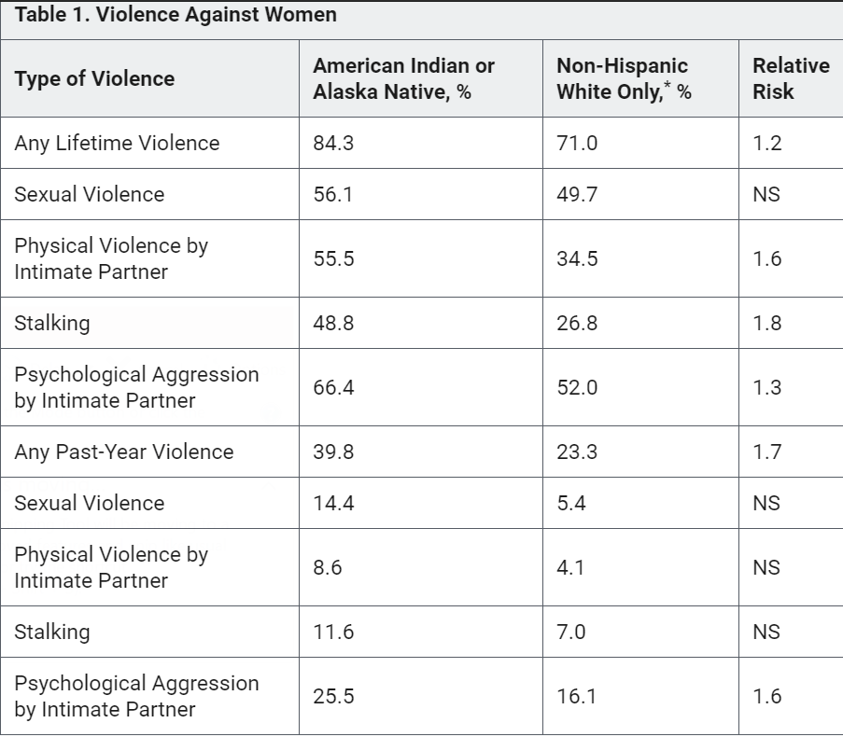  - Violence against men  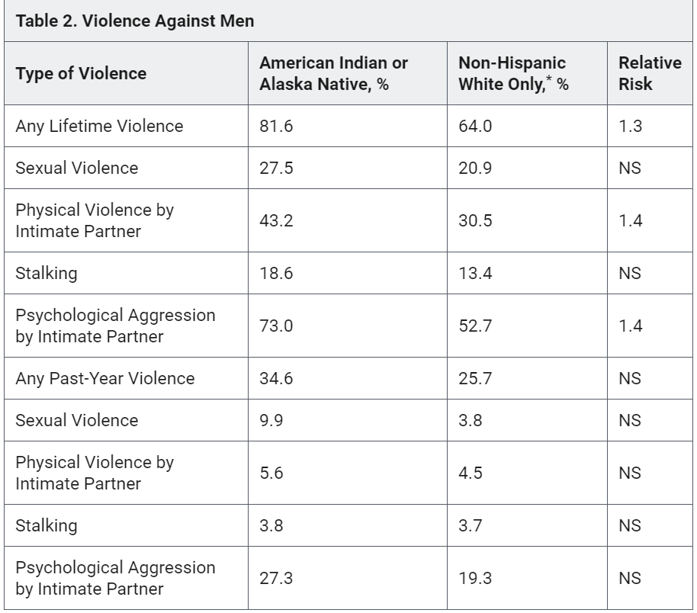  - Federal government was suppose to have responsibility to help tribal governments in providing safety of the Indian women  - Contradicts with the US Supreme court (1978) ruling that “tribes did not have criminal jurisdiction over non-indian perpetrators”  - In other words, non-indian offenders were not allowed to be criminally prosecuted by federally recognized tribes because they don’t have the authority to do so  - The Violence Against Women Reauthorization Act of 2013  - Somewhat corrected this problem  - It forces tribes that are federally recognized with “special domestic violence criminal jurisdiction”  - In other words, allows tribes to prosecute certain cases that would involve non-indian offenders, if they meet the conditions given  How does the Violence Affect Victims?  - 66.5% women and 26% men expressed concern for their safety  - 41.3% of women and 20.3% men were physically injured  - 49% women and 19.9% men needed services  - 40.5% women and 9.7 men missed days of school or work  - 1.5 times as likely as non- hispanic white-only female victims to be physically injure,  - 1.9 times as likely to miss school or work days,  - 1.8 times as likely to need services  - Services needed  - 16% legal  - 11% housing  - 9% advocacy  - Male victims commonly reported needing legal services, and medical care  - 1:3 AI & ANF or 39%; 1:6 AI & ANM or 17%, weren’t able to get the services needed  - The women were “2.5 times as likely as non-hispanic white-only women to lack access to needed services”  Addressing the Problem  - Report given of how the government needed to provide services for AI’ and Alaska Native victims of crime  - https://ovc.ncjrs.gov/vision21/pdfs/Vision21_Report.pdf  https://nij.ojp.gov/media/image/19456  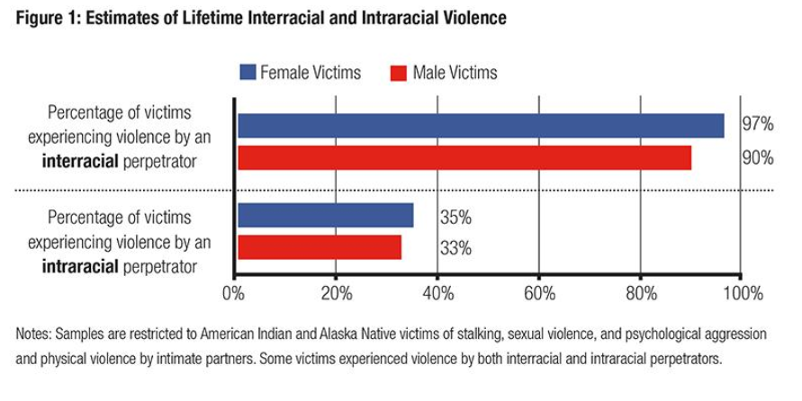
2/11 7pm - 7:52pm | Invisible Indians  (Journal Article)  Pennsylvania  3/7pages read | Pg 61.  - “There are no Indians in Pennsylvania”  - Public institutions did not say they existed within that state  - Pennsylvania is one of few states that does not provide reservation or officially recognize any Native American tribes/groups  - Controversy due to Pennsylvania being the first to have contact with Native Americans when the Europeans came  Facts:  - In 2000, 18,348 people within the state of Pennsylvania were Native American  - Occasional newspaper stories about school programs/patriotic celebrations talking about the local Native americans  - Questionnaire surveys were circulated to find out what Native Americans knowledge of themselves  - Descendants of the Lenape/Delaware  - Susquehannocks/Pennsylvania  - Mohawks, Senecas, Six Nations, Iroquois  Pg 62.  - “The state of Pennsylvania needs to recognize us. We are the only nationality that must prove we are who we say we are….I served as a Marine in 1970-73. I hold down a job, pay my taxes, help put my kids through school, but yet because we have native ancestors, we are second class citizens to Pennsylvanians.” (Lenape Man)  - Governor Rendell oppose recognition to Native americans  - Federal appeals court stripped the Oklahoma Delawares of their federal recognition allowing land to be purchased by Native americans  - No legal standing to make a request for proper burials  - William Penn destroyed native land claims in the 17th century  Pg. 63  - Collision and fights between other tribes  - Prevents unity  Restoring Native American Identity in Pennsylvania  - Nationwide Native American identity is one of many majjor issues for native populations  - Identity issues having both legal and personal consequences  - “When you’re that way and you can’t find where you’re supposed to be, there’s a piece of that whole history and culture that’s missing.” (NA)  - He feels this way because he was not raised on a reservation, he’s not with his people because he’s of mixed blood
2/12 9- 9:30am | Boarding schools  (Website)  ⅓ read  Years = 1940s-1970s | Floyd Red Crow Westerman (Indian Activist) [His time during Wahpeton Indian Boarding School in North Dakota]  - “You put me in your boarding school, made me learn your white man rule, be a fool.”  - Haunted by memories of boarding school  - As a child, he went from his reservation in South Dakota to his North Dakota boarding school  - He was forced far away from his home and tribe  Bill Wright (Pattwin Indian) [5th grader at the Stewart Indian School in Nevada]  - First started school when he was 6  - Bathed him in kerosene and shaved his head  - Still has nightmares from severe discipline from boarding school  - He lost his language and his indian name  - “I remember coming home and my grandma asked me to talk indian to her and I said, ‘Grandma, I don’t understand you,’  - “She said,’Then who are you?’”  - “‘You name’s not Billy. Your name’s ‘TAH-rruhm,’”  - ‘That’s not what they told me.’”  - “You grow up with discipline, but when you grow up and you have families, then what happens? If you’re my daughter and you leave your dress out, I’ll knock you through that wall. Why? Because I’m taught discipline,”  Col. Richard H. Pratt’s speech of 1892 [first of the off-reservation Native American boarding schools]  - “A great general has said that the only good Indian is a dead one, and that high sanction of his destruction has been an enormous factor in promoting Indian massacres.”  - “That all the Indiana there is in the race should be dead. Kill the Indian in him, and save the man.”  Early History  - US government believed Indians were savages, those who should be compelled to send their children to schools to education  - 1870s was when the federal government began sending the Native Americans to off-reservation boarding schools  Boarding schools  - Federal boarding schools forbid them from expressing their culture  - Can’t wear long hair  - Cant’ speak a single indian work  - Almost 100 boarding schools, off and on reservations  - Children were often taken by armed police forcibly  - Public schools were closed to Indians due to racism  - Boarding school curriculum was focused on trade  - Carpentry for boys  - Housekeeping for girls  - Watched movies like  - Cowboys and indians  Abuse  - Children were beaten  - Malnourished  - Forced into doing heavy labour  - 1 case  - Bill Wright remembered an adviser abusing a student  - “Busted his head open and bloot got all over,” “I had to take him to the hospital, and they told me to tell them he ran into the wall and I better not tell them what really happened.”  Tsianina Lomawaima [head of American Indian Studies program at University of Arizona]  - Their intention was to completely transform them from the inside out  - Language, family structure,economics, religion, express of emotion, way of income  Report that declared Indian Education a national tragedy  - 1928, The Problem of Indian Administration or Meriam Report  - Lewis Meriam, superviser  - Found children at federal boarding schools in states of overworking children, harsh punishment, poor education, lack of food and nutrients  - Not the ratio of toilets to students  - Were not properly maintained  - Not enough soap and towels  - Not enough food  - They lock the door to the fire escape of the girls’ dormitory  - Only sort of exercise given is military drilling and only to highschool boys  - Many of the teachers still believe that it is their role as that of “civilizing the native”
2/12 1:20-2pm | Sovereignty & Treaty Rights  (Journal Article)  8/9 pages read | Pg. 141  - Federal law  - Tribal government cannot prosecute a non-reservation no matter how heinous or trivial  - Cannot prosecute a reservation  - member for muder, rape, robbery, or other felony  Pg. 142  - Most Native American governments have no police power over most of the people within reservations  - Doubtful that tribal governments can regulate land use effectively  - NAtive American governments lack practice of legitimate sovereign power  - Due to lack of granted power by federal government  - Indian Reorganization Act of 1934  - “An act of the US Congress. Besides being severely limited in scope, those powers can be amended, or eliminated for that matter, at the whim of Congress  - Sovereign powers practiced by contemporary tribal governments are more of a dream than reality  - Business committees can be easily eliminated by Congress  - Self-Determination and Educational Assistance Act = illusory  - No more than permission to administer housing, health, education, and community development or any other programs given by Public Health Service or Bureau of Indian Affairs  - Administrators must follow the rules, guidelines, regulations given by the federal government  Pg. 145  - “Federal policy makers have known the political significance of Native American languages for ages and, consequently, made eradication of native languages a priority in the boarding schools of yesteryear.”  - This allowed Native Americans under the age of 30 to be able to speak their native tongue  - International Law  - The Native Americans need to be classified as their own race before claiming any measure of sovereignty  Pg. 146  - No living language = no inherent sovereignty or distinctive people  Pg. 147  - Indian Appropriation Act of 1871  - “No Indian nation or tribe within the territory of the US shall be acknowledged or recognized as an independent nation, tribe, or power with whom the US may contact by treaty..”  - They (Native americans) don’t get the same nor equal treatment as the other treaties have  - Due to N.A government lack of independent existence, any treaty rights they might have had were taken away
2/14 Grade #2: 100%
WOW! Wonderful work Gemma!
3/10 2:50- 3:15 | Stewart Indian School Nevada  (primary) | - Opened in 1890, december 17 with 37 students from Washoe, Paiute, and Shoshone tribes, with 3 teachers  - Ultimate goal was assimilation  - Max capacity of 100 students  - Buildings included dormitory, school housing, training, a hospital, and a recreation room  - Transporting of students was given  - 1919, 400 students attended  - Students  - Learned stone masonry  - Hopi stone masons  - Constructed over 60 native stone buildings  - Student curriculum  - Reading, writing, arithmetic  - Focused on on vocational training in various trades, agriculture, and the service industry  - Boys  - Ranching and farming, mechanics, painting, woodworking, carpentry  - Girls  - Baking, sewing, cooking, laundry, nursing  - 1980’s = closed due to earthquake safety issues with masonry buildings and federal budget cuts  - 1990’s  - Used by state for classes, agency offices, training, and the Nevada Indian commission
3/26  1:14 - 1:36pm  1:50 - 2:10pm | Sherman Indian highschool | - Until 1960s, government tried to ban the teaching of culture  - Got punishments if they stepped out of line or disregarded the rules  - If they woke up late  - Don’t do their duties  - Clean the bathrooms  - Clean the dorms  - Sheila Patterson  - From San Carlos Apache Reservation in Southeast Arizona  - Left her reservation due to large amount of people drinking and committing suicide  - “That’s why I had to get away and come here,”  - She felt the need to leave and escape  - Most students go to Sherman as a way out of their toxic community  - National graduation rate is 50% for Native Americans  - Zero tolerance for alcohol and drugs  - Can leave campus if earned a group activity  - Administrators even say that they maintain a tightly controlled environment  - “A lot of other Indian tribes in the United States have lost use of their language and therefore their culture.” Eddie Biakeddy - deputy director of the Navajo tribe department of Education  - Steve Yankton - student from Pine Ridge Reservation in Southwest South Dakota  - “We’re always confined in a fence,” “ We really can’t live high-school life like regular teenagers would. We can’t just go shop at the mall whenever we want for how long we want. We can’t go eat at a restaurant with our friends whenever we feel like we want. Staff always has to be around us.”  Pros of Sherman  - Offers them the chance to learn about other tribes  - Tara Charley-Baugus - teacher  - Learn the language of the Dine which is Navajo  - Sing traditional songs  - “And you can teach these to your brothers and sisters. That’s how you pass on the language”  - Teachers like Baugus and Lorene Sisuoc are trying to revive Native American customs  - Lorene Sisquoc  - Tradition skills  - Basket weaving
3/26  2:11- 2:33pm | Sherman Indian High School Website | - Off-reservation boarding highschool  - Opened in 1892 as the Perris Indian School  - Relocated in 1903 to riverside and was called The Sherman Institute  - Around 76 federally recognized tribes represented by the students  - Have a cultural museum with artifacts from the opening of the school  - Language material form tribes such as  - Apache, navajo, cherokee, juaneno, gabrielino, yavapai samish, choctaw, karuk, samala chumash, blackfoot, athabaskan, serrano, cahuilla, luiseno, chicasae, tohono o’odham, puma, lakota, hualapai, passamaqwaddy, mohawk, tlingit, ojibwe, yokut  - Native tradition Classroom - Instructor Lorene Sisquoc  - Learning basketry, boarding school history, traditional values, native toys and games, native plant uses, pottery, native foods, music and instruments, Southern California Indian material culture, etc  - Lorene’s classroom is a cultural resource for public classes and staff
3/26  3:02- 2:53pm | Narratives of Boarding School Life  14/26 pages read  Pg. 97-110 | Pg. 97  - Duffy Gayton - Went to Albuquerque Indian School between the 1930s - early 1940s  Pg 98  - Hopi Don Talayesva - Sherman Institute in Riverside, California  - Extreme alienation, loneliness, illness  - Focused on enjoying the sports side instead  - John fire/Lame Deer - Sherman Institute  - Cold, inhuman place of drudgery and discipline  - But enjoyed sports  - “I think in the end I got the better of that school. I was more of an Indian when I left than when I went in.”  - Sports were a positive light to them despite the negative memories in general of the boarding schools  Pg. 100  - Many who were interviewed were very passionate about their sports experience within their boarding school  Pg. 105  - Arthur Harris - member of the Yavapai tribe near Prescott, Arizona  - “When I was a child, about six or seven, I remember … that the government awfully forceful to give the Indians, young Idnians, and education. There was a, a boarding school there, and I remember, us youngsters used to would go up on the hills and, and make a, a rock wall in a, in a cave, we’d hide there so the, the, the policeman, the Indian policeman wouldn’t see us to take us to school. We used to hide there quite a bit, but later on some were caught and they put’em in school….But I was not caught, I was the only child at the time.”  Pg. 106  - San Carlos Reservation boarding school  - Arthur Harris - 9-10 when he started school  - “They gave me good clothes”  - “..they cut my hair off, and they give me good clipping so a new crop would come up. I remember that very well, and give me a place, give me underclothes, nice clothes to wear. I took a bath in tub, they didn’t have no showers them days so I had a tub bath…”  - He only wore a flour sack to cover below his waist before he went to school  - He wasn’t allowed to speak Yavapai at school  - Forced to speak english
3/27  5:58- 6:40pm | Sherman Institute  30/30 pages read | Pg. 194  - Southern California  - Rather than “boxing” the native Americans into reservations, the reformers pushed to educate them and “civilize(Americanize)” them  - Achieved through schooling  - Industrial work  - Training in western methods of agriculture  - Carlisle Indian School in Pennsylvania  - Aim = “Kill the Indian and save the man,” as Richard H. Pratt, founder of the school  - Native americans would be taught the culture, language, and traits of the white  Pg. 203  - Perris Indian School  - Ms. Estelle Reel, superintendent of Indian Schools (June 1-3, 1899)  - Saw their Lack of water  - Hard to maintain its agricultural program  - Harwood Hall, Head of Perris Indian School  - Wanted a more suitable site for the school when seeing the lack of water as well in (august, 1899)  - Advocated the moving the school to another location  - Was his idea to move to the Riverside Valley  - Richard H.Pratt superintendent of Carlisle Indian School in Pennsylvania  - Spoke against Perris Indian School’s move  - “Proper locations can be found in the vicinity of redlands, San Bernardino, Los Angeles, Pasadena, or San Diego.”  Pg. 214  - Buildings  - “Ramona Home”  - women  - “Alessandro Lodge”  - Men  Pg. 219  - May 1902, Sherman Institute was opened to students
3/27  6:42-7pm | From Boarding Schools to the Multicultural classroom  6/14 pages read | Pg. 85  - Boarding schools had serious negative impact  - On language and spirituality  - Forced their tribal languages and their customs from the children by separating them from their families  - Punished severely the children that were culturally informed  - Hampton normal School & Carlisle Indian school  - Provided American-based education  - Some attendees were prisoners of the US, but offered a choice between death and school  - Captain Richard Henry Pratt  - “I believe in immersing the Indians in our civilization and when we get them under, holding them there until they are thoroughly soaked.”  - Chippewa student - student from 1954-1960  - “The beatings we received at boarding school were often. They were done with belts, rulers, and hands. There was no question before or after them. Sometimes when someone ran away, they were beaten with a rubber hose and their heads shaved. Afterwards they were paraded in front of other students. I equated my treatment with being Indian and concluded that sadness, hunger, pain, and loneliness were an India’s natural state and that I was unworthy of fair or just treatment. I believed that I should be ashamed of myself-not angry. I took other peoples’ values and opinions as facts.
3/28  8:40 - 8:55pm | Boarding Schools struggling with cultural repression | - Teacher humiliated and made fun of their traditions  - Military discipline and ways  - Uniforms  - Marching  - Boarding schools were often extremely based on christianity
3/28  9:58- 10:05pm | A day in the life of a Native Indian American | - Native Men  - Named after an elder or ancestor  - Changed later in life to describe heroic acts  - Focused on fighting and horsemanship  - Focused on being brave and tough  - At the age of 17, left to become a man  - Followed the “guardian spirit” which allowed them to be ready for battle or to hunt food for their family  - Animals were sacred  - Native women  - Held a very important role in their society that without them, “the tribe would cease to exist”  - Pitch tipis or move them if tribe relocates  - Incharge of tanning hides, skinning buffalo  - Pray and cook  - Gathering  - Berries, nuts, etc  - Native Children  - Different for each tribe  - Plains Native Tribes  - Cared by parents  - Never beaten  - Strength is vital to a tribe  - Crying is not acceptable  - Moved to a different location if crying wasn’t stopped  - Children copied parents to learn how to live and perform daily activities  - Boys  - on toy horses  - Find their spirit animals between ages 14-17  - Most of younger years were of training for battle and hunting  - Girls  - making tipis and playing with dolls made from deer skin  - Rituals and religion  - Major part of life  - Tribes honouring their ancestors by often holding big ceremonies with the entire tribe
3/28  10:06- | Native American Cultures | - Seperated in America before Christopher Columbus arrived  - Arctic  - SubArctic  - Northeast  - Southeast  - Plains  - Southwest  - Great Basin  - California  - Northwest Coast  - The Plateau

