World Religions Day 5
Small Group Discussions on Hinduism, Gods, & Bhakti Yoga
For the first part of today's class you will work in small groups. This will be the main part of your class participation grade for today. You are expected to work together in your small group; stay on-task, discuss together, and take a few notes about what you learn and discuss.
- Quickly review what you have learned about The 4 Stages of Hinduism Religious Philosophy.
- Quickly review what you have learned about The 4 Different Types of Yoga.

- Now we will discuss one of the main THEMES of this World Religions Class: are there different ways of knowing religions and religious truths? This concept of different ways of knowing comes from the IB program TOK (Theory of Knowledge) Course.

3a. Look at this chart from the IB Program and discuss what you think it means with your small group:

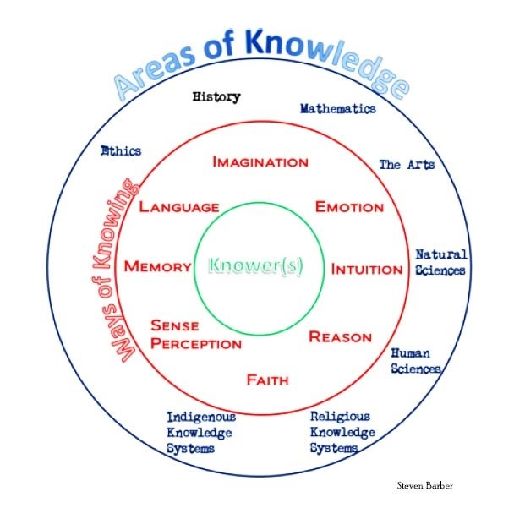

- We will use a similar approach in this World Religions class. We will explore if there are different ways of knowing religious truths? Discuss these questions with your group:

4a. What would it mean to 'know religious truth' through using your "Reason" and "Language"? Give some examples. Explain.

4b. What would it mean to 'know religious truth' through using "Faith"? Give some examples. Explain.

4c. What would it mean to know religious truth through using "Intuition"? Give some examples. Explain.

4d. What would it mean to know religious truth through using "Emotion"? Give some examples. Explain.

4e. What would it mean to know religious truth through using "Experience"? Give some examples. Explain.

4f. Which of these ways of knowing do you personally think is 'the best way' for knowing religious truths and why?

- How does what you have learned about Hinduism so far (especially about the different types of yoga) relate to this concept of 'different ways of knowing'?

- Let's focus on RAJA YOGA. This is the type of yoga we have been doing in class- physical yoga and formal meditation. Which of the ways of knowing best fits with RAJA YOGA?

6a. What are your personal opinions, reactions, questions, comments about the raja yoga we have been doing in class so far?

- Let's focus on JNANA YOGA. This is the type of yoga using discussion, teaching, readings, and reflection. Which of the ways of knowing best fits with JNANA YOGA?

- Now let's shift focus to BHAKTI YOGA. This is the yoga of Hinduism worshipping many gods and goddesses through thousands of years of stories, rituals, and ceremonies.

- First you individually MUST open up on my website the handout called "Week 3 Bhakti Yoga Readings"

- On this handout individually only read PAGE 47 "THOU BEFORE WHOM ALL WORDS RECOIL". After you read page 47 by yourself discuss the main ideas of page 47 with your group.

- On the same handout individually read PAGES 28-29 "THE WAY TO GOD THROUGH LOVE" After you read pages 28-29 by yourself then discuss the main ideas of pages 28-29 with your group.

- Next take out your own PORTFOLIO. Take turns showing and talking about your Portfolio Page due for homework today about 2 gods or goddesses. Take turns talking about what you learned about your 2 gods of goddesses.

- When you have finished this- raise your hand and tell the teacher you are finished.

