Bob Marley/Reggae Songs Inspired by the Books of the Prophets of Judaism
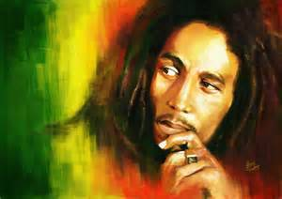
- By the Rivers of Babylon 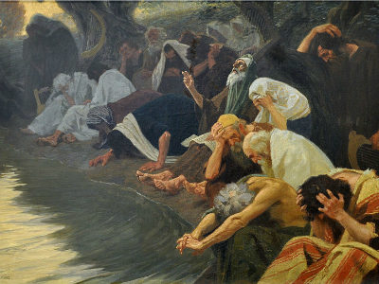

By the rivers of babylon, there we sat down
Ye-eah we wept, when we remembered zion
By the rivers of babylon, there we sat down
Ye-eah we wept, when we remembered zion
When the wicked
Carried us away in captivity
Required from us a song
Now how shall we sing the lord's song in a strange land
When the wicked
Carried us away in captivity
Required of us a song
Now how shall we sing the lord's song in a strange land
Let the words of our mouth and the meditations of our heart
Be acceptable in thy sight here tonight
Let the words of our mouth and the meditation of our hearts
Be acceptable in thy sight here tonight
By the rivers of babylon, there we sat down
Ye-eah we wept, when we remembered zion
By the rivers of babylon, there we sat down
Ye-eah we wept, when we remembered zion
By the rivers of babylon (dark tears of babylon)
There we sat down (you got to sing a song)
Ye-eah we wept, (sing a song of love)
When we remember zion (yeah yeah yeah yeah yeah)
By the rivers of babylon (rough bits of babylon)
There we sat down (you hear the people cry)
Ye-eah we wept, (they need their god)
When we remember zion (ooh, have the power)

- Bob Marley- Forever Loving Jah
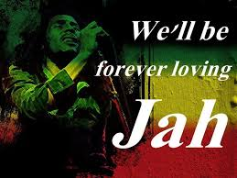
Woah-oh, ya-ya-ya-ya, oy-oh
Yeah-yeah-yeah, yeah-yeah, yeah-yeah-yeah-yeah
Oh (we'll be forever loving Jah)
(We'll be forever loving Jah)
Some, they say, see them
Walking up the street
They say we're going wrong
To all the people we meet
But-a we won't worry
We won't shed no tears
We found a way
To cast away the fears, forever, yeah
we'll be forever
(We'll be forever loving Jah) forever, yes
And forever (we'll be forever loving Jah) there'll be no end
So, old man river
Don't cry for me
I've got a running stream
Of love, you see
So, no matter what stages
Oh stages, stages, stages they put us through
We'll never be blue
No matter what rages
Oh rages, changes, rages they put us through
We'll never be blue
We'll be forever, yeah
we'll be forever
(We'll be forever loving Jah) forever, and ever
Yes, and forever (we'll be forever loving Jah) 'cause there is no end
'Cause only a fool
Lean upon, lean upon his own misunderstanding, oh, yeah
And then what has been hidden
From the wise and the prudent, been revealed to the babe and the suckling
In everything, in every day, I say, yeah
we'll be forever
(We'll be forever loving Jah)
'Cause just like a tree
Planted, planted by the rivers of water
That bringeth forth fruits
Bringeth forth fruits in due season
Everything in life got its purpose
Find its reason
In every season, forever, yeah
we'll be forever
(We'll be forever loving Jah) on and on and on
(We'll be forever loving Jah) we'll be forever, yes, yes, we'll be forever
(We'll be forever loving Jah)

- Bob Marley- Thank you Lord
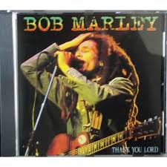
Thank you, Lord, for what you've done for me.
Thank you, Lord, for what you're doing now.
Thank you, Lord, for ev'ry little thing.
Thank you, Lord, for you made me sing.
Say I'm in no competition,
But I made my decision.
You can keep your opinion.
I'm just calling on the wise man's communion.
Thank you, Lord, for what you've done for me.
Thank you, Lord, for what you're doing now.
Thank you, Lord, for ev'ry little thing.
Thank you, Lord, for you made me sing.
Sing along, sing along.
I don't fear their humiliation,
Just to prove my determination.
I don't yield to temptation,
I haven't learn't my lesson in Revelation.
Thank you, Lord, for what you've done for me.
Thank you, Lord, for what you're doing now.
Thank you, Lord, for ev'ry little thing.
Thank you, Lord, for you made me sing.
Sing along, sing along.
Say I'm in no competition
But I made my decision,
Lord, in my simple way.
Comin', comin', comin', comin'.
I love to pray.
Thank you, Lord, for what you've done for me.
Thank you, Lord, for what you're doing now.
Thank you, Lord, for ev'ry little thing.

- Bob Marley- Small Axe
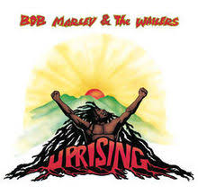
Why boasteth thyself, O evil men
Playing smart and-a not being clever!
I said you're working iniquity
To achieve vanity (if a-so, a-so),
But the goodness of Jah - Jah
Endureth for ever
So if you are the big tree,
We are the small axe
Ready to cut you down, (well sharp)
To cut you down
These are the words of my master
Keep on tellin' me: no weak out shall prosper
Eh! Whosoever diggeth a pit
Shall fall in it - fall in it
And whosoever diggeth a pit
Shall fall in it (fall in it)
If you are the big tree,
Let me tell you that: we are the small axe
Sharpened ready ready to cut you down, (well sharp)
To cut you down.
(Ooh-ooh-ooh-ooh-ooh, to cut you down,
Ooh-ooh-ooh-ooh-ooh, to cut you down)
These are the words of my master
Tellin' me that: no weak out shall prosper
And whosoever diggeth a pit
Shall fall in it, uh! bury in it!
And whosoever diggeth a pit
Shall bury in it, uh! (bury in it)
If you are the big, big tree,
We are the small axe
Ready to cut you down, (well sharp)
To cut you down
If you are the big, big tree,
Let me tell you that: we are the small axe
Ready to cut you down, (well sharp)
To cut you down

