Primary Documents used on the Unit 6 Test

Primary Source 1A: New Deal Government Poster
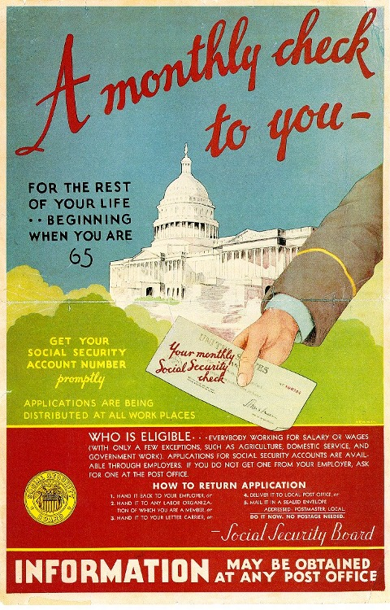

Primary Source 1B: FDR Re-Nomination Acceptance Speech at Democratic National Convention
Today we stand committed to the proposition that freedom is no half-and-half affair. If the average citizen is guaranteed equal opportunity in the polling place, he must have equal opportunity in the market place. These economic royalists complain that we seek to overthrow the institutions of America. What they really complain of is that we seek to take away their power. Our allegiance to American institutions requires the overthrow of this kind of power. In vain they seek to hide behind the Flag and the Constitution. In their blindness they forget what the Flag and the Constitution stand for. Now, as always, they stand for democracy, not tyranny; for freedom, not subjection; and against a dictatorship by mob rule and the over-privileged alike…. Better the occasional faults of a Government that lives in a spirit of charity than the consistent omissions of a Government frozen in the ice of its own indifference. There is a mysterious cycle in human events. To some generations much is given. Of other generations much is expected. This generation of Americans has a rendezvous with destiny.

Primary Source 2A:
Langston Hughes poem "Harlem"
What happens to a dream deferred?
Does it dry up
like a raisin in the sun?
Or fester like a sore—
And then run?
Does it stink like rotten meat?
Or crust and sugar over—
like a syrupy sweet?
Maybe it just sags
like a heavy load.
Or does it explode?

Primary Source 2B: Excerpt from Harriot Stanton Blatch book We, the American Women
“The day I visited the place, in one of the largest shops women had only just been put on the work, but it was expected in less than a month they would be found handling all of the twelve hundred machines under that one roof alone. The skill of women staggers one. After a week or two they master the operations on the ‘turret,’ gauging and routing machines. The best worker on the ‘facing’ machine is a woman. She is a piece worker, as many of the women are...This woman earned, the day I saw her, five dollars and forty cents. She tossed about the fuse parts, and played with that machine, as I would with a baby.”

Primary Source 3A: Newspaper Headline Page from Manila, Phillippines
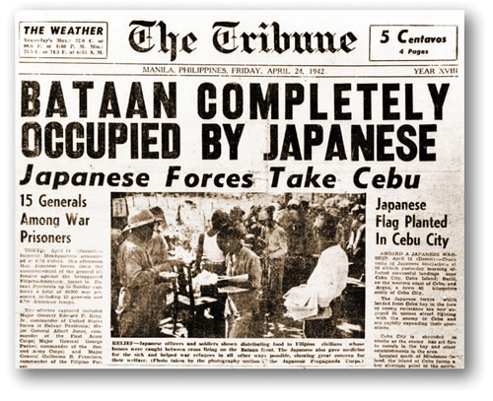

Primary Source 3B: A letter from Kenji Okuda to Norio Higano from Camp Harmony about his feelings on internment on Memorial Day,
"Dear Norio-sen
On this first Memorial Day after our fateful entrance into a frightening, devastating war . . . thousands of young Americans have already perished and other thousands are fighting furiously dying and killing . . . . there is nothing in this camp to remind us of that occasion except a memorial service this evening at 7. No military parade will we see; no valiant, half-hearted display of armed might . . . just a quiet service for those Japanese pioneers who have died striving that we, their children, might inherit something of that Great American ideal, Democracy.
But how futile and hypocritical this all sounds . . . in concentration camps in a Democracy . . . to be kept herein at the sole discretion of the military . . . and yet to be expected to be willing to do our best to insure the defeat of a nation with which so many of us are connected only by facial and racial characteristics."-

