Taipei American School: IB Psychology SL/HL 2022-2023
Teacher: Mr. Chris Ciambarella
Email: ciambarellac@tas.edu.tw
Class Website: www.mrciambarellaclass.com

COURSE OBJECTIVES
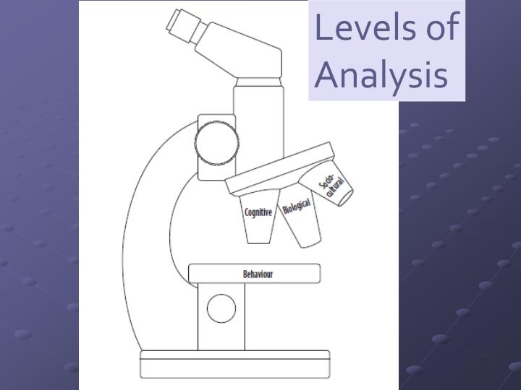 | I hope IB Psychology will be one of the most interesting, enjoyable, and helpfully practical classes you take. We will explore & discuss different approaches to studying human behavior from a biological, cognitive, and sociocultural perspective- with a special emphasis on ‘health psychology’ and understanding & coping with stress & addiction in teenagers. As an IB class you will also greatly improve your academic writing skills, which should also be greatly helpful & practical to you.  Psychology is the scientific study of behavior and mental processes. Psychology has its roots in both the natural and social sciences, leading to a variety of research designs and applications, and providing a unique approach to understanding modern society.  IB psychology examines the interaction of biological, cognitive and sociocultural influences on human behavior, thereby adopting an integrative approach. Understanding how psychological knowledge is generated, developed and applied enables students to achieve a greater understanding of themselves and appreciate the diversity of human behavior. The ethical concerns raised by the methodology and application of psychological research are key considerations in IB psychology. Students will also design and conduct an enjoyable and interactive experimental study in psychology, as the internal assessment for the IB.

First semester units | Second semester units
- Introduction to Psychology & Research  - Sociocultural Approach (Paper 1)  - Cognitive Approach (Paper 1)  - Finish Internal Assessment  -Group experiment & individual report  - Paper #1 Practice & Semester Exam | - Biological Approach (Paper 1)  - Health Psychology (Paper 2)  -focus on stress & addiction  - Review for Paper 1 & 2  - Prepare for May Exam
HL vs SL and IB External Exam Overview
Students enrolled in IBSL Psychology only take this class this year and are required to take the external IB examination in May 2023. Students who are enrolled in IBHL Psychology Year 1 will study HL topics next year as well and then take the external IB examination the following year in May 2024.
IB assessment summary for SL Students
 | Content | Format | Weight
Paper 1 | Biological, cognitive, and sociocultural levels of analysis (LOA) | - 2 hours  - 3 compulsory SAQs (one on each LOA)  - Choose 1 of 3 ERQs essay questions | 50 %
Paper 2 | Health psychology | - 1 hour  - Choose 1 of 3 essay questions | 25 %
Internal assessment | Fun group experiment based on a real Psychological study & individual written report.  Experimental research methodology, descriptive statistics and graphing, formal academic writing | - Formal APA style research report | 25 %

IB assessment summary for HL Students
 | Content | Format | Weight
Paper 1 | Biological, cognitive, and sociocultural levels of analysis (LOA)- with HL extension topics:  Biological extension- “animal research”  Cognitive extension- “digital technology”  Sociocultural extension- “globalization” | - 2 hours  - 3 compulsory SAQs (one on each LOA)  - Choose 1 of 3 ERQs essay questions | 40 %
Paper 2 | Health psychology & Abnormal Psychology | - 2 hours  - Choose 2 of 3 essay questions | 20 %
Internal assessment | Fun group experiment based on a real Psychological study & individual written report.  Experimental research methodology, descriptive statistics and graphing, formal academic writing | - Formal APA style research report | 20%
Paper 3 | Testing Quantitative & Qualitative Research Methods  Read an abstract of an actual study and analyze it.  Question 1 always 3 parts:  - Research Method used  - Sampling Method used  - Alternative methods could use  Question 2 always about Research Ethics  Question 3 about analyzing Qualitative Research of Study | - 1 hour  - 3 compulsory questions | 20%

CLASSROOM EXPECTATIONS

Assessment

Students earn two grades for this class – one from TAS, and one from the IBO. TAS grades are assigned by the instructor based on coursework and assessments (see Upper school student/parent handbook). While assessment methods are somewhat varied, the heavy weighting of written assessments by the IBO demands that tests will be similarly weighted in this class. Students can expect one or two formal assessments per unit following the style of the IB Psychology exam (short answer and essay responses). A significant portion of the student’s grade will also be based on class participation, as this course is designed to be largely a student-centered and discussion-based class.

Grading policy
First Semester  50% Written Assessments- IB Exam practice for Paper 1  20% Internal Assessment (Process & Final Paper)  10% Classwork & Homework  10% Class Participation  10% 1st Semester Final Exam (Mock IB Paper #1 Exam) | Second Semester  60% Written Assessments- IB Exam practice for Paper 2  and Paper 1  25% Classwork & Homework  15% Class Participation

Unless there is a prior agreement with the teacher, all assignments are due at the beginning of class on the scheduled due date. An assignment not submitted at this time will be considered a late submission, and will incur a penalty for each school day that the assignment is late. Excuses related to deficiencies in technology are not accepted. Deductions begin from the start of the class when an assignment is due; a minute late is a day late. Unless there is a prior agreement with the teacher before class…you also must take any assessments given in class when you are present in class.

Computer Etiquette: The use of technology in the classroom is a privilege, not a right. At no point should your computer be used for streaming of videos messaging, social media or emailing—even other teachers—in the middle of class.

Plagiarism: Carefully review the school’s official statement on academic dishonesty. Know that plagiarism is a serious offense and will result in severe consequences. Examples of plagiarism include, but are not limited to, consulting tutors for ideas, passing off other students’, regardless of whether they attend T.A.S. or not, work as your own and using quotations by other authors without proper citations. All work that students submit must be exclusively their own unless material is appropriately and accurately cited in correct format.
All major assignments will be submitted to the Turnitin program where any instances of plagiarism will be found. Anyone found in the act of plagiarism will be sent to the US office and will receive a penalty on the assignment. **see your student handbook for the school policy on academic dishonesty**

Participation: Participation is a significant portion of students’ final grades. Contributions should reflect careful consideration of texts, be relevant, and add deeper understanding of the significance of the historical event. The combined quality and quantity of comments will be considered in scoring. Students should respect classmates by listening actively and responding with considerate but challenging comments. This score also includes daily factors such as level of engagement, active listening, note-taking, classwork, contribution to group work, attentiveness, and punctuality. Success in this class depends on students’ active engagement with the material each day.

EXTRA HELP
I am available during Flex and during my lunch in the Social Studies Office for students to receive extra help. In order to make sure you get to see me, please make arrangements to meet with me in case other students need help. A student who schedules ahead will be seen before one who arrives unannounced. I am also available by scheduled appointment after school. Students are highly encouraged to be proactive about their progress in my class. It is certainly my pleasure to help make the school year productive and enjoyable!

