PROJECT #3 US History Trial of Malcolm X
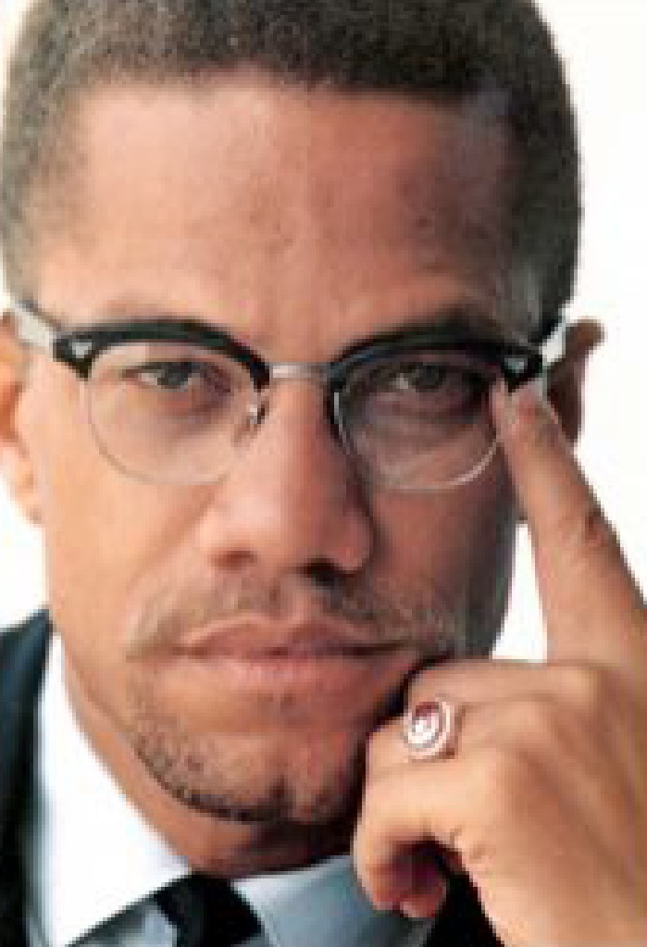 | 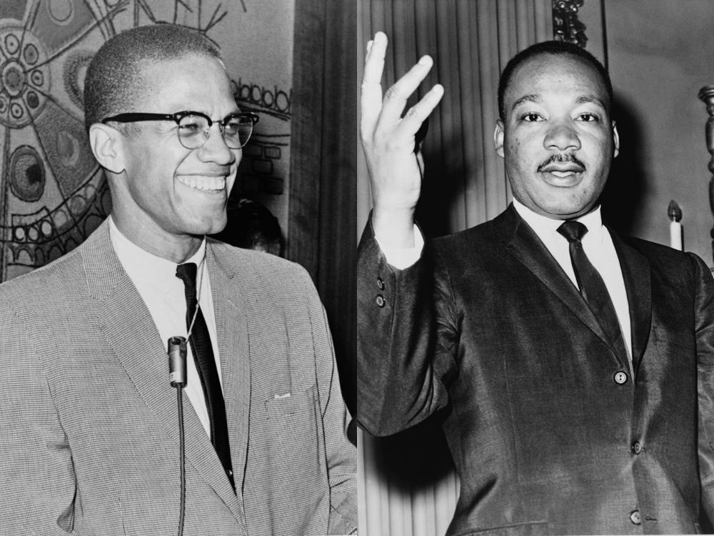
Overview: We will put Malcolm X on Trial. In specific we will put Malcolm X's ideas on 3 topics on Trial. You will either work on the Prosecution Team or Defense Team. Within the teams you can either be a lawyer or witness or both; of course, we need someone to play Malcolm X also.
The actual Trial will be on April 19 (A-Day) & April 20 (B-Day)
We do NOT have a traditional Unit 7 Test on the Civil Rights Movement; instead, this Trial will count as a 60-point "Project" grade.
Your Grade:
- 30 points- your Preparation for the Trial (your research notes + final trial outline
- 30 points- your Participation & Performance on Trial Day

What is the Entire Content of the Trial?/What do I need to do now?:
-We are putting Malcolm X's IDEAS on Trial. In specific, we are putting his ideas on 3 Topics related to the US Civil Rights Movement on Trial.
-You need to decide if you agree (Defense-side) or if you disagree (Prosecution-side) with Malcolm X's ideas.
-You need to decide which of the 3 topics you want to focus on for your part of the Trial.
-You need to decide if you want to be a lawyer, witness, or both.

I.Topic #1 on Trial: Malcolm X's View on The Overall Blueprint of the Civil Rights Movement
Integration vs. Separation
-As we will soon see in our study of the US Civil Rights Movement, one divide in the movement involves the issue of integration vs. separation. Martin Luther King will argue that integration must always be at the heart of the movement; in other words, African-Americans and minorities should integrate with white America in all parts of the movement. White people should be allowed in the movement and stand alongside African-Americans in all parts of the movement. African-Americans and other minorities should have the ultimate goal also be integration into mainstream, "white" America. The goal is for African-Americans to slowly integrate into "white America" now through sit-ins and other forms of protest, with the goal that eventually minorities will be gradually integrated as equals into all parts of US society.
-Malcolm X disagrees with the blueprint and goal of integration; instead, Malcolm X calls for separation of African-Americans from mainstream "white" America. First of all, protests and other struggles in the movement should be done exclusively by African-Americans and minorities themselves. If "whites" take part in the movement it will diminish the power and revolutionary nature of the movement itself. In addition, if African-Americans truly want "equality" in the USA they must first separate themselves from "white America" and build up the strength of their communities themselves. Only then will white America respect African-Americans and consider them equal. If African-Americans try to integrate into white America first they will never garner the strength to achieve true equality. So the overall blueprint for the Civil Rights Movement should not be integration and then granted equality; instead, it should be separation then forced equality.
-So this is Topic #1 of the Trial. Do you agree or disagree with Malcolm X's view?
-The Prosecution Side will disagree with Malcom's view of the blueprint for the movement. You will give evidence why Malcolm X's ideas here are incorrect.
-The Defense Side will agree with Malcolm X's view of the blueprint for the movement. You will give evidence why Malcolm X's ideas here are correct.
IMPORTANT POINTS to mention NOW:
- Some of your evidence should come from Unit 7 on the Civil Rights Movement.
- However, some of your evidence should also come from other time periods of US History- both past history and/or modern-day US society.
- FYI: A lot of this evidence could prove very useful on our FINAL 2nd Semester FINAL EXAM.

II.Topic #2 on Trial: Malcolm X's View on The Methods of The Civil Rights Movement
Nonviolence vs. "By Any Means Necessary"
-As we will also soon see in our study of Unit 7, another split in the movement revolves around the methods and means to be used in the Civil Rights Movement. You probably already know that Martin Luther King will insist that Total Nonviolence must be at the heart of everything in the movement. Even in the face of extreme brutality and violence, all participants in the Civil Rights Movement must be completely and forever committed to never using any form of violence. Therefore, we will see the use of nonviolent methods such as peaceful sit-ins, marches, and speeches, etc.
-Although it must be mentioned that Malcolm X will never himself participate in any acts of violence as part of the Civil Rights Movement, Malcolm X disagrees that the movement must always and forever only use nonviolent methods. His famous phrase is that he will achieve equality "by any means necessary": if nonviolence works then great, but if it doesn't work then African-Americans have the right to consider other options also. Malcolm X argues this is only acting as a true American acts- Americans who have used guns and violence to fight for equality all through USA History. If George Washington can use violence for equality and be a hero, why can't the African-American do the same, especially in the face of extreme violence and brutality? Finally, Malcolm X will criticize a lot of the nonviolent methods we will study in this Unit as ineffective and beneath the dignity of African-Americans (what's the point of allowing a police dog to bite a peaceful girl protesting or allow a policeman to spray water hoses at her?)
-So this is Topic #2 of the Trial. Do you agree or disagree with Malcolm X's view?
-The Prosecution Side will disagree with Malcom's view of the methods used in the movement. You will give evidence why Malcolm X's ideas here are incorrect.
-The Defense Side will agree with Malcolm X's view of the methods used for the movement. You will give evidence why Malcolm X's ideas here are correct.
IMPORTANT POINTS to mention again NOW:
- Some of your evidence should come from Unit 7 on the Civil Rights Movement.
- However, some of your evidence should also come from other time periods of US History- both past history and/or modern-day US society.
- FYI: A lot of this evidence could prove very useful on our FINAL 2nd Semester FINAL EXAM.

III.Topic #3 on Trial: Malcolm X's View of the overall GOAL of the movement
The American Dream vs The American Nightmare
-Topic #3 steps back and asks the big picture question: are African-Americans (and other minorities) truly better off living in the USA or not? For Martin Luther King the answer is yes. The USA (and Christianity) already have the perfect ideas: equality, democracy, and brotherly love. Now African-Americans and other minorities just need to work together to make these ideals a reality. This is the essence of Martin Luther King's famous "I Have a Dream" speech. So the ultimate goal of the Civil Rights Movement is for African-Americans to stay and become part of a true United States of America.
Malcolm X on the other hand is not afraid to ask the question of maybe "The American Dream" is actually only an "American Nightmare" for African-Americans and other minorities. More important than ideals is maybe reality; and for Malcolm X the reality is that living in the USA has always been- and will always be- a nightmare for African-Americans and minorities. From slavery to segregation to police brutality the USA is a dangerous and nightmarish place for African-Americans. Similarly, Malcolm X believes that Christianity is "the white man's religion" and is a religion designed to keep whites in control over minorities. This is the religion of the slavemaster and it is meant to control its slaves. Therefore, Malcolm X believes that African-Americans must turn towards a different religion for salvation, and it should be a religion started by people of color. For Malcolm X, the only religion to assist African-Americans is Islam. So, unlike Martin Luther King who sees the end goal in the USA, Malcolm X wants African-Americans to join the larger international struggle of people of color where perhaps the USA is the enemy?
-So this is Topic #3 of the Trial. Do you agree or disagree with Malcolm X's view?
-The Prosecution Side will disagree with Malcom's view of the goal of the movement. You will give evidence why Malcolm X's ideas here are incorrect.
-The Defense Side will agree with Malcolm X's view of the goal of the movement. You will give evidence why Malcolm X's ideas here are correct.
IMPORTANT POINTS to mention again NOW:
- Some of your evidence should come from Unit 7 on the Civil Rights Movement.
- However, some of your evidence should also come from other time periods of US History- both past history and/or modern-day US society.
- FYI: A lot of this evidence could prove very useful on our FINAL 2nd Semester FINAL EXAM.

What to do now?
- Start deciding if you want to be on The Prosecution Side or Defense Side Overall
- Decide which of the 3 Topics you want to focus on for your part of the Trial
- Start to collect "evidence" that you could use in the Trial (and maybe on your Final Exam). Remember look for evidence from BOTH Unit 7 The Civil Rights Movement AND also look for evidence from past US History and modern USA.

We will choose our Teams and Roles for the Trial in class on 4/15 (A-Day) and 4/16 (B-Day)
You will have all class on that day to work on your Trial Notes and Outline
Then we will do our best to have the Trial in class on 4/19 A-Day and 4/20 B-Day
Like all “project grades” it should be fun and relaxing. Just do your best!

