PRIMARY DOCUMENTS USED on 2020 2nd SEMESTER FINAL EXAM
On the Final Exam you will need to analyze only ONE of the following primary documents. You will see they are grouped according to "Guiding Statements" or 'Themes", but you still choose to analyze any ONE document you want.

Guiding statement A:
"In the 21st century, America's foreign policy objectives undermined its standing in the international community as a champion of human rights."
Primary source document 1 for Guiding statement A:
"Today, I speak with you about a radical idea. It is one born from the very concept of the American soldier (or service member). It became instrumental in ending the Vietnam War – but it has been long since forgotten. The idea is this: that to stop an illegal and unjust war, the soldiers can choose to stop fighting it… The American soldier must rise above the socialization that tells them authority should always be obeyed without question. Rank should be respected but never blindly followed.
Awareness of the history of atrocities and destruction committed in the name of America – either through direct military intervention or by proxy war – is crucial. They must realize that this is a war not out of self-defense but by choice, for profit and imperialist domination. WMD, ties to Al Qaeda, and ties to 9/11 never existed and never will.
The soldier must know that our narrowly and questionably elected officials intentionally manipulated the evidence presented to Congress, the public, and the world to make the case for war. They must know that neither Congress nor this administration has the authority to violate the prohibition against preemptive war – an American law that still stands today. This same administration uses us for rampant violations of time-tested laws banning torture and degradation of prisoners of war. Though the American soldier wants to do right, the illegitimacy of the occupation itself, the policies of this administration, and rules of engagement of desperate field commanders will ultimately force them to be party to war crimes. They must know some of these facts, if not all, in order to act." Lt. Ehren Watada, US Army Lieutenant who faced court-martial for refusing to serve in the Iraq War, August 14, 2006.
Primary source document 2 for Guiding statement A:
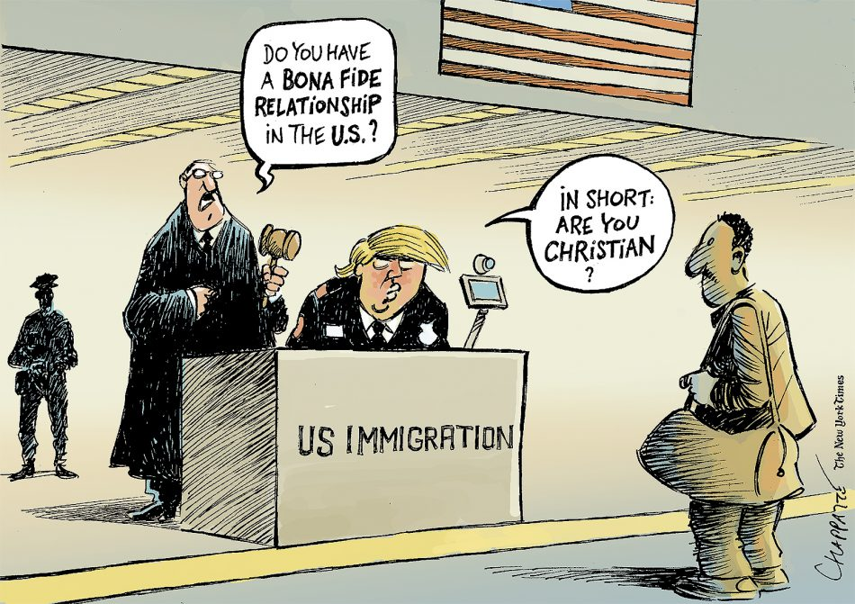
"The Supreme Court and Trump's Travel Ban" by Patrick Chappatte, The International New York Times, June 30, 2017.

Guiding statement B: "In the 21st century, America's domestic policy objectives reflected the goals and needs of an increasingly diverse population."

Primary source document 1 for Guiding statement B:
"The Constitution promises liberty to all within its reach, a liberty that includes certain specific rights that allow persons, within a lawful realm, to define and express their identity. The petitioners in these cases seek to find that liberty by marrying someone of the same sex and having their marriages deemed lawful on the same terms and conditions as marriages between persons of the opposite sex. . . No union is more profound than marriage, for it embodies the highest ideals of love, fidelity, devotion, sacrifice, and family. In forming a marital union, two people become something greater than once they were. As some of the petitioners in these cases demonstrate, marriage embodies a love that may endure even past death. It would misunderstand these men and women to say they disrespect the idea of marriage. Their plea is that they do respect it, respect it so deeply that they seek to find its fulfillment for themselves. Their hope is not to be condemned to live in loneliness, excluded from one of civilization’s oldest institutions. They ask for equal dignity in the eyes of the law. The Constitution grants them that right." Obergefell v Hodges, Supreme Court case upholding same-sex marriage, June 26, 2015.

Primary source document 2 for Guiding statement B:
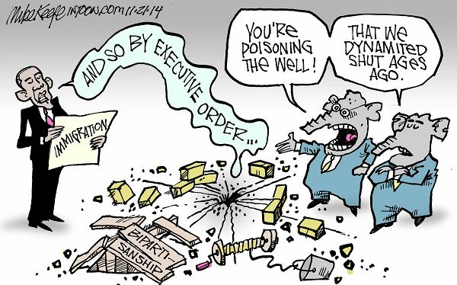
“Executive Order” by Mike Keefe, Intoon.com, November 21, 2014.

Guiding statement C: "In the 20th and 21st centuries, minorities in America gained total equality through civil rights and social movements."
Primary source document 1 for Guiding statement C:
"[The] law in this country constitutionally guarantees that a citizen or group of citizens may assemble and petition their government, or their governmental authorities, for redress of their grievances even by mass demonstrations as long as the exercise of these rights is peaceful. These rights may also be exercised by marching, even along public highways, as long as it is done in an orderly and peaceful manner; and these rights to assemble, demonstrate and march are not to be abridged by arrest or other interference so long as the rights are asserted within the limits of not unreasonably interfering with the exercise of the rights by other citizens to use the sidewalks, streets and highways, and where the protesters and demonstrators are conducting their activities in such a manner as not to deprive the other citizenry of their police protection. . . [It] seems basic to our constitutional principles that the extent of the right to assemble, demonstrate and march peaceably along the highways and streets in an orderly manner should be commensurate with the enormity of the wrongs that are being protested and petitioned against. In this case, the wrongs are enormous. The extent of the right to demonstrate against these wrongs should be determined accordingly. " Williams v Wallace, court case authorizing the Selma to Montgomery march to demand equal voting rights, 1965.

Primary source document 2 for Guiding statement C:

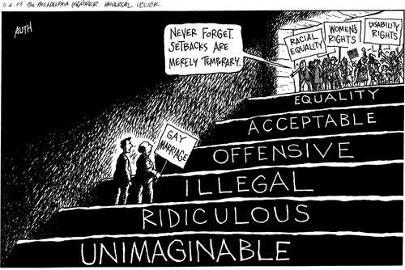
"Gay Marriage," by Tony Auth, Philadelphia Inquirer, November 2009.

